SNUG-2008
Boston, MA
Voted Best Paper
1st Place

World Class Verilog & SystemVerilog Training
Clock Domain Crossing (CDC) Design & Verification
Techniques Using SystemVerilog
Clifford E. Cummings
Sunburst Design, Inc.
cliffc@sunburst-design.com

ABSTRACT
Important design considerations require that multi-clock designs be carefully constructed at
Clock Domain Crossing (CDC) boundaries. This paper details some of the latest strategies and
best known methods to address passing of one and multiple signals across a CDC boundary.
Included in the paper are techniques related to CDC verification and an interesting 2-deep FIFO
design for passing multiple control signals between clock domains. Although the design methods
described in the paper can be generally implemented using any HDL, the examples are shown
using efficient SystemVerilog techniques.
Table of Contents
1.0
Introduction........................................................................................................................... 6
2.0
Metastability.......................................................................................................................... 6
2.1
Why is metastability a problem?........................................................................................... 7
3.0
Synchronizers........................................................................................................................ 8
3.1
Two synchronization scenarios............................................................................................. 8
3.2
Two flip-flop synchronizer ................................................................................................... 8
3.3
MTBF - mean time before failure......................................................................................... 9
3.4
Three flip-flop synchronizer ............................................................................................... 10
3.5
Synchronizing signals from the sending clock domain....................................................... 10
3.6
Synchronizing signals into the receiving clock domain...................................................... 11
4.0
Synchronizing fast signals into slow clock domains .......................................................... 13
4.1
Requirement for reliable signal passing between clock domains ....................................... 13
4.1.1
The "three edge" requirement.......................................................................................... 13
4.2
Problem - passing a fast CDC pulse ................................................................................... 14
4.3
Problem - sampling a long CDC pulse - but not long enough!........................................... 15
4.4
Open-loop solution - sampling signals with synchronizers ................................................ 16
4.5
Closed loop solution - sampling signals with synchronizers .............................................. 17
5.0
Passing multiple signals between clock domains ............................................................... 18
5.1
Multi-bit CDC strategies..................................................................................................... 18
5.2
Multi-bit signal consolidation............................................................................................. 18
5.3
Problem - Two simultaneously required control signals..................................................... 19
5.3.1
Solution - Consolidation.................................................................................................. 20
5.4
Problem - Two phase-shifted sequencing control signals................................................... 21
5.4.1
Solution - consolidation and an extra flip-flop................................................................ 22
5.5
Problem - Multiple CDC signals......................................................................................... 23
5.5.1
Solutions for passing multiple CDC signals.................................................................... 23
5.6
Multi-Cycle Path (MCP) formulation................................................................................. 24
5.6.1
MCP formulation using a synchronized enable pulse ..................................................... 25
5.6.2
Closed-loop - MCP formulation with feedback .............................................................. 27
5.6.3
Closed-loop - MCP formulation with acknowledge feedback ........................................ 28
5.7
Synchronizing counters....................................................................................................... 29
5.7.1
Binary counters................................................................................................................ 29
5.7.2
Gray codes ....................................................................................................................... 30
5.7.3
Gray-to-binary conversion............................................................................................... 30
5.7.4
Binary-to-gray conversion ............................................................................................... 31
5.7.5
Gray code counter style #1 .............................................................................................. 32
5.7.6
Gray code counter style #2 .............................................................................................. 33
5.8
Additional multi-bit CDC techniques................................................................................. 34
5.8.1
Multi-bit CDC signal passing using asynchronous FIFOS.............................................. 34
5.8.2
Multi-bit CDC signal passing using 1-deep / 2-register FIFO synchronizer................... 35
6.0
Naming conventions & design partitioning ........................................................................ 36
6.1
Clock & signal naming conventions................................................................................... 36
6.1.1
Multi-clock / multi-source modules with no naming convention................................... 37
6.2
Timing verification for each clock domain......................................................................... 37
6.3
Clock oriented design partitioning...................................................................................... 37
6.3.1
Timing analysis of clock-partitioned modules................................................................. 39
6.4
Partitioning with MCP formulations................................................................................... 40
7.0
Multi-clock gate-level simulation issues ............................................................................ 41
7.1
Synchronizer gate-level CDC simulation issue .................................................................. 41
7.2
Strategies to remove X-propagation from gate-level simulations....................................... 41
7.2.1
Simulator command to turn off timing checks ................................................................ 42
7.2.2
Change flip-flop setup and hold times to 0...................................................................... 42
7.2.3
Copy and modify new flip-flop models........................................................................... 42
7.2.4
Synopsys set_annotated_check command....................................................................... 42
7.3
Additional strategies to remove X-propagation.................................................................. 43
7.3.1
Use multiple SDF files .................................................................................................... 43
7.3.2
Vendor synchronizer cell with supporting SDF generation tools.................................... 43
7.3.3
Vendors with built-in synchronizer support .................................................................... 44
7.4
Multiple SDF files for gate-level CDC simulations ........................................................... 44
7.5
Force synchronizer notifier inputs to a fixed value............................................................. 44
7.6
ASIC & FPGA library cell synchronizers........................................................................... 45
7.7
Simulation model with random delay insertion.................................................................. 46
8.0
Summary & conclusions ..................................................................................................... 47
8.1
Recommended 1-bit CDC techniques................................................................................. 47
8.2
Recommended multi-bit CDC techniques .......................................................................... 48
8.3
Recommended naming conventions and design partitioning ............................................. 48
8.4
Recommended solutions to multi-clock gate-level CDC simulations ................................ 48
9.0
Acknowledgements............................................................................................................. 48
10.0 References........................................................................................................................... 48
11.0 Author & Contact Information............................................................................................ 49
12.0 Appendix............................................................................................................................. 50
12.1 Common sync2 model - used by MCP formulation and FIFO synchronizer...................... 50
12.2 MCP formulation with ready-acknowledge source code.................................................... 50
12.3 Multi-bit 1-deep / 2-register FIFO synchronizer source code............................................. 55
Table of Figures
Figure 1 - Asynchronous clocks and synchronization failure......................................................... 6
Figure 2 - Metastable bdat1 output propagating invalid data throughout the design................... 7
Figure 3 - Two flip-flop synchronizer............................................................................................. 9
Figure 4 - Primary contributing factors to short MTBF values..................................................... 10
Figure 5 - Three flip-flop synchronizer used in higher speed designs.......................................... 10
Figure 6 - Unregistered signals sent across a CDC boundary....................................................... 11
Figure 7 - Registered signals sent across a CDC boundary .......................................................... 12
Figure 8 - Short CDC signal pulse missed during synchronization.............................................. 14
Figure 9 - Marginal CDC pulse that violates the destination setup and hold times...................... 15
Figure 10 - Lengthened pulse to guarantee that the control signal will be sampled..................... 16
Figure 11 - Signal with feedback to acknowledge receipt ............................................................ 17
Figure 12 - Problem - Passing multiple control signals between clock domains.......................... 19
Figure 13 - Solution - Consolidating control signals before passing between clock domains ..... 20
Figure 14 - Problem - Passing sequential control signals between clock domains....................... 21
Figure 15 - Solution - Logic to generate proper sequencing signals in the new clock domains... 22
Figure 16 - Problem - Encoded control signals passed between clock domains .......................... 23
Figure 17 - Logic to pass a synchronized enable pulse between clock domains .......................... 24
Figure 18 - Synchronized pulse generation logic.......................................................................... 25
Figure 19 - Synchronized enable pulse generation logic and equivalent symbol ......................... 26
Figure 20 - Multi-Cycle Path (MCP ) formulation toggle-pulse generation................................. 26
Figure 21 - Multi-Cycle Path (MCP ) formulation toggle-pulse generation with acknowledge... 27
Figure 22 - Multi-Cycle Path (MCP ) formulation toggle-pulse generation with ready-ack ........ 28
Figure 23 - Binary count values sampled in mid-transition.......................................................... 29
Figure 24 - 4-bit gray-to-binary conversion equations.................................................................. 30
Figure 25 - 4-bit gray-to-binary conversion equations - 2nd method ........................................... 31
Figure 26 - 4-bit binary-to-gray conversion equations.................................................................. 31
Figure 27 - Gray code counter style #1 - only one gray code register........................................... 32
Figure 28 - Gray code counter style #2 - binary register and gray code register........................... 33
Figure 29 - 1-deep / 2-register FIFO synchronizer block diagram................................................ 35
Figure 30 - Design partitioned on clock boundaries..................................................................... 38
Figure 31 - Partitioned design with MCP formulation ................................................................. 40
Figure 32 - Synchronizer gate-level CDC simulation waveforms................................................ 41
Figure 33 - Sample ASIC & FPGA synchronizer cell for synthesis and simulation .................... 46
Table of Examples
Example 1 - Non-working but conceptually correct gray-to-binary SystemVerilog model ......... 30
Example 2 - Parameterized and correct gray-to-binary SystemVerilog model............................. 31
Example 3 - Parameterized binary-to-gray SystemVerilog model................................................ 32
Example 5 - Parameterized gray-code counter SystemVerilog model.......................................... 33
Example 6 - Parameterized gray-code counter with binary counter ............................................. 34
Example 7 - SystemVerilog model for ASIC & FPGA synchronizer cell.................................... 47
Example 8 - sync2.sv code............................................................................................................ 50
Example 9 - plsgen.sv code .......................................................................................................... 50
Example 10 - asend_fsm.sv code.................................................................................................. 51
Example 11 - back_fsm.sv code ................................................................................................... 51
Example 12 - bmcp_recv.sv code ................................................................................................. 52
Example 13 - mcp_blk.sv code..................................................................................................... 53
Example 14 - acmp_send.sv code................................................................................................. 54
Example 15 - wctl.sv code............................................................................................................ 55
Example 16 - cdc_syncfifo.sv code .............................................................................................. 55
Example 17 - Dual Port Ram code - dp_ram2.sv ......................................................................... 56
Example 18 - rctl.sv code.............................................................................................................. 56

1.0 Introduction
In 2001, I presented my first paper on multi-asynchronous clock design. At that time, I had not
found any good sources to describe the design and synthesis techniques required to do proper
multi-clock design. The 2001 paper was a collection of techniques that I had gathered over years
from actual ASIC and FPGA design experiences. At the conclusion of the 2001 conference
presentation, dozens of engineers and colleagues came forward and shared with me enough
additional interesting ideas and techniques to write a sequel on the topic. Over the past eight
years, I have included instruction on multi-clock design techniques in my Advanced and Expert
Verilog and SystemVerilog training courses, and over that same period of time, more colleagues
and students have shared with me additional interesting multi-clock design techniques. Since the
release of the first multi-clock paper in 2001, the industry has largely identified these types of
design methodologies as Clock Domain Crossing (CDC) techniques. I will use this common
nomenclature in this paper.
This paper includes the best techniques described in the 2001 paper along with an updated
collection of interesting and efficient multi-clock design techniques that have been shared with
me over the past decade. The actual conference presentation slides will be mostly a collection of
the new techniques incorporated since the original 2001 presentation, retaining only enough of
the original slides to introduce the fundamental CDC design concepts and issues.

2.0 Metastability
Metastbility refers to signals that do not assume stable 0 or 1 states for some duration of time at
some point during normal operation of a design. In a multi-clock design, metastability cannot be
avoided but the detrimental effects of metastability can be neutralized.
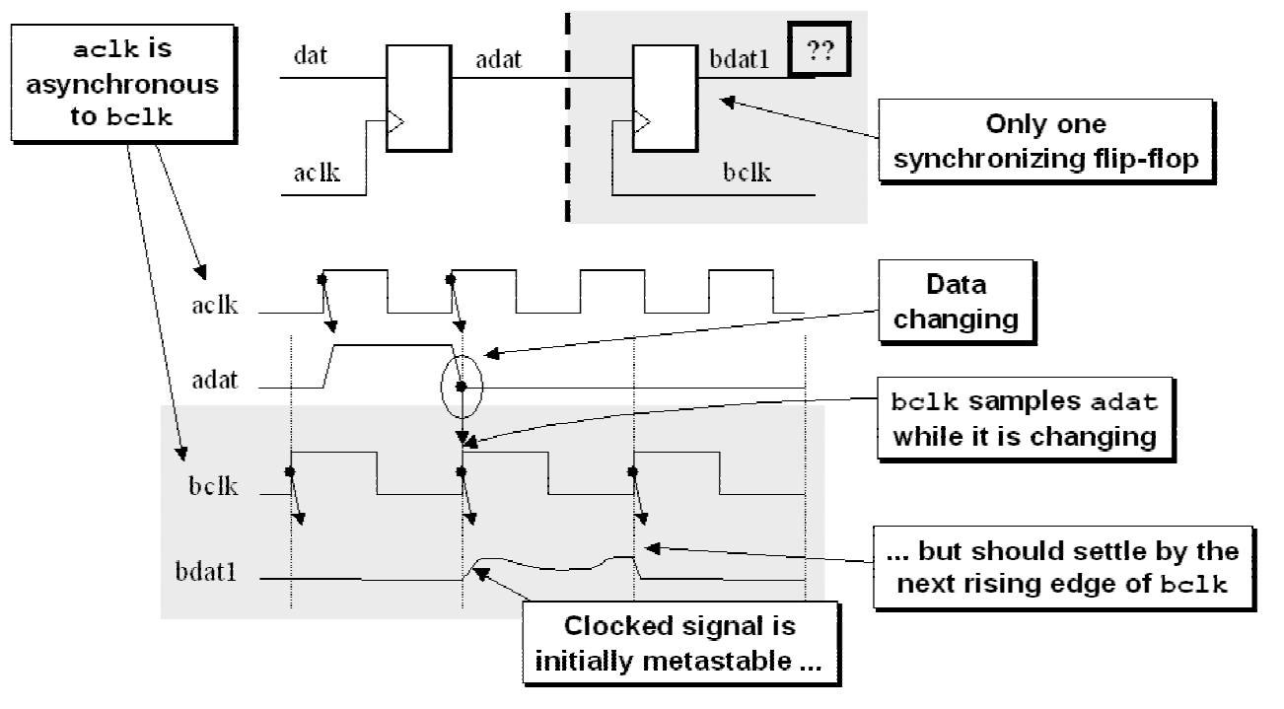
Figure 1 - Asynchronous clocks and synchronization failure
Quoting from Dally and Poulton's book[9] concerning metastability:
"When sampling a changing data signal with a clock ... the order of the events
determines the outcome. The smaller the time difference between the events, the
longer it takes to determine which came first. When two events occur very close
together, the decision process can take longer than the time allotted, and a
synchronization failure occurs."
Figure 1 shows a synchronization failure that occurs when a signal generated in one clock
domain is sampled too close to the rising edge of a clock signal from a second clock domain.
Synchronization failure is caused by an output going metastable and not converging to a legal
stable state by the time the output must be sampled again.

2.1 Why is metastability a problem?
So why is metastability a problem? Figure 2 shows that a metastable output that traverses
additional logic in the receiving clock domain can cause illegal signal values to be propagated
throughout the rest of the design. Since the CDC signal can fluctuate for some period of time, the
input logic in the receiving clock domain might recognize the logic level of the fluctuating signal
to be different values and hence propagate erroneous signals into the receiving clock domain.
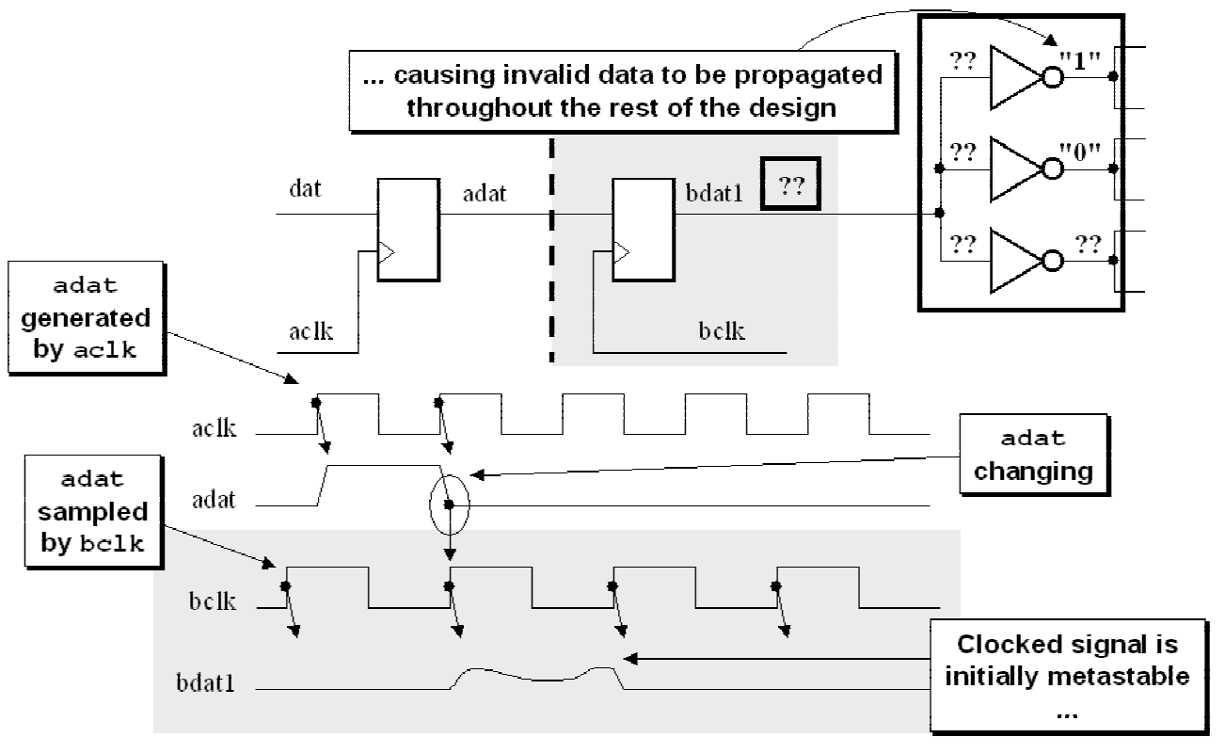
Figure 2 - Metastable bdat1 output propagating invalid data throughout the design
Every flip-flop that is used in any design has a specified setup and hold time, or the time in which
the data input is not legally permitted to change before and after a rising clock edge. This time
window is specified as a design parameter precisely to keep a data signal from changing too close
to another synchronizing signal that could cause the output to go metastable.

3.0 Synchronizers
When passing signals between clock domains, an important question to ask is, do I need to
sample every value of a signal that is passed from one clock domain to another?

3.1 Two synchronization scenarios
There are two scenarios that are possible when passing signals across CDC boundaries, and it is
important to determine which scenario applies to your design:
(1) It is permitted to miss samples that are passed between clock domains.
(2) Every signal passed between clock domains must be sampled.
First scenario: sometimes it is not necessary to sample every value, but it is important that the
sampled values are accurate. One example is the set of gray code counters used in a standard
asynchronous FIFO design. In a properly designed asynchronous FIFO model, synchronized gray
code counters do not need to capture every legal value from the opposite clock domain, but it is
critical that sampled values be accurate to recognize when full and empty conditions have
occurred.
Second scenario: a CDC signal must be properly recognized or recognized and acknowledged
before a change is permitted on the CDC signal.
In both of these scenarios, the CDC signals will require some form of synchronization into the
receiving clock domain.

3.2 Two flip-flop synchronizer
Quoting again from Dally and Poulton[9] concerning synchronizers:
"A synchronizer is a device that samples an asynchronous signal and outputs a version
of the signal that has transitions synchronized to a local or sample clock."
The simplest and most common synchronizer used by digital designers is a two-flip-flop
synchronizer as shown in Figure 3.
The first flip-flop samples the asynchronous input signal into the new clock domain and waits for
a full clock cycle to permit any metastability on the stage-1 output signal to decay, then the stage-
1 signal is sampled by the same clock into a second stage flip-flop, with the intended goal that
the stage-2 signal is now a stable and valid signal synchronized and ready for distribution within
the new clock domain.
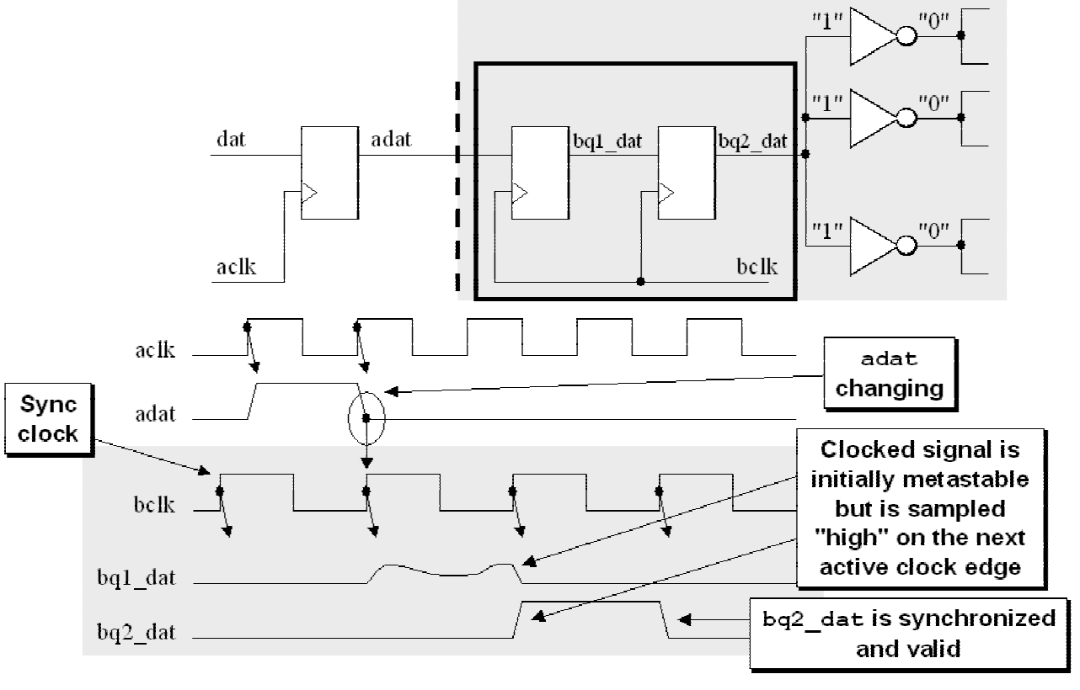
Figure 3 - Two flip-flop synchronizer
It is theoretically possible for the stage-1 signal to still be sufficiently metastable by the time the
signal is clocked into the second stage to cause the stage-2 output signal to also go metastable.
The calculation of the probability of the time between synchronization failures (MTBF) is a
function of multiple variables including the clock frequencies used to generate the input signal
and to clock the synchronizing flip-flops. One description of the MTBF calculation can be found
in Dally and Poulton[9].
For most synchronization applications, the two flip-flop synchronizer is sufficient to remove all
likely metastability.

3.3 MTBF - mean time before failure
For most applications, it is important to run a calculation of the Mean Time Before Failure
(MTBF) for any signal crossing a CDC boundary. Failure in this sense means a signal that is
passed to a synchronizing flip-flop, goes metastable on the first stage synchronizer flip-flop, and
continues to be metastable one cycle later when it is sampled into the second stage synchronizer
flip-flop. Since the signal did not settle to a known value after one clock cycle, the signal could
still be metastable when sampled and passed to the receiving clock domain, causing potential
failures to the corresponding logic.
When calculating MTBF numbers, larger numbers are preferred over smaller numbers. Larger
MTBF numbers indicate longer periods of time between potential failures, while smaller MTBF
numbers indicate that metastability could happen frequently, similarly causing failures within the
design.
Dally and Poulton[9] give a good equation with very thorough analysis of the calculation that can
be performed to calculate the MTBF of a synchronizer circuit. Without repeating the equation
and analysis, it should be pointed out that two of the most important factors that directly impact
the MTBF of a synchronizer circuit are, the sample clock frequency (how fast are signals being
sampled into the receiving clock domain) and the data change frequency (how fast is the data
changing that crosses the CDC boundary).
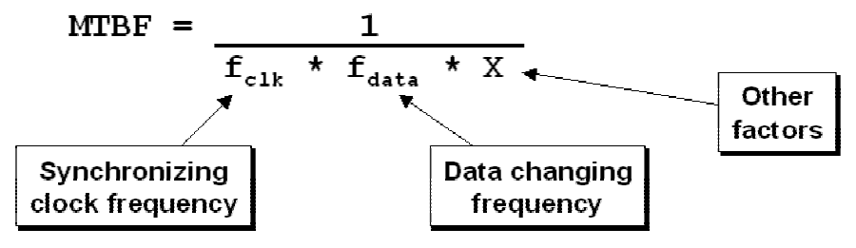
Figure 4 - Primary contributing factors to short MTBF values
From the above partial equation, it can be seen that failures occur more frequently (shorter
MTBF) in higher speed designs, or when the sampled data changes more frequently.

3.4 Three flip-flop synchronizer
For some very high speed designs, the MTBF of a two-flop synchronizer is too short and a third
flop is added to increase the MTBF to a satisfactory duration of time. Of course, satisfactory is
determined by the architect of the design.
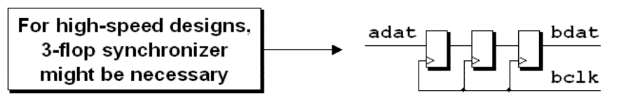
Figure 5 - Three flip-flop synchronizer used in higher speed designs

3.5 Synchronizing signals from the sending clock domain
Frequently asked question regarding CDC design: Is it a good idea to register signals from
the sending clock domain before passing the signals to the receiving clock domain? Implied in
the question is the assumption that CDC signals will be synchronized into the receiving clock
domain; therefore, they do not require synchronization in the sending clock domain. This
rationalization is incorrect and registering signals in the sending clock domain should generally
be required.
Consider an example where the signals in the sending clock domain are not registered before
being passed into the receiving clock domain, as shown in Figure 6.
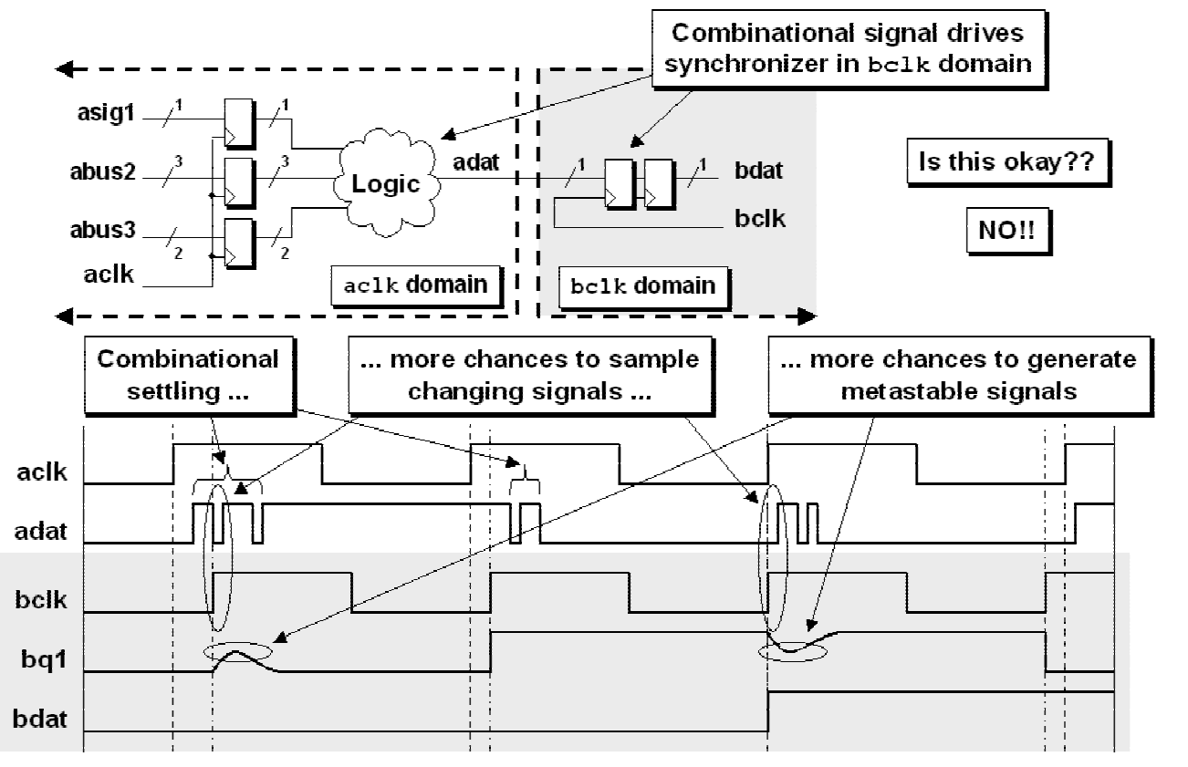
Figure 6 - Unregistered signals sent across a CDC boundary
In this example, the combinational output from the sending clock domain could experience
combinational settling at the CDC boundary. This combinational settling effectively increases the
data-change frequency potentially creating small bursts of oscillating data and thereby increasing
the number of edges that could be sampled while changing, with a corresponding increase in the
potential for sampling changing data and generating metastable signals.

3.6 Synchronizing signals into the receiving clock domain
Signals in the sending clock domain should be synchronized before being passed to a CDC
boundary. The synchronization of signals from the sending clock domain reduces the number of
edges that can be sampled in the receiving clock domain, effectively reducing the data-change
frequency in the MTBF equation and hence increasing the time between calculated failures (see
section 3.3 for a description of the impact of data change frequencies on MTBF).
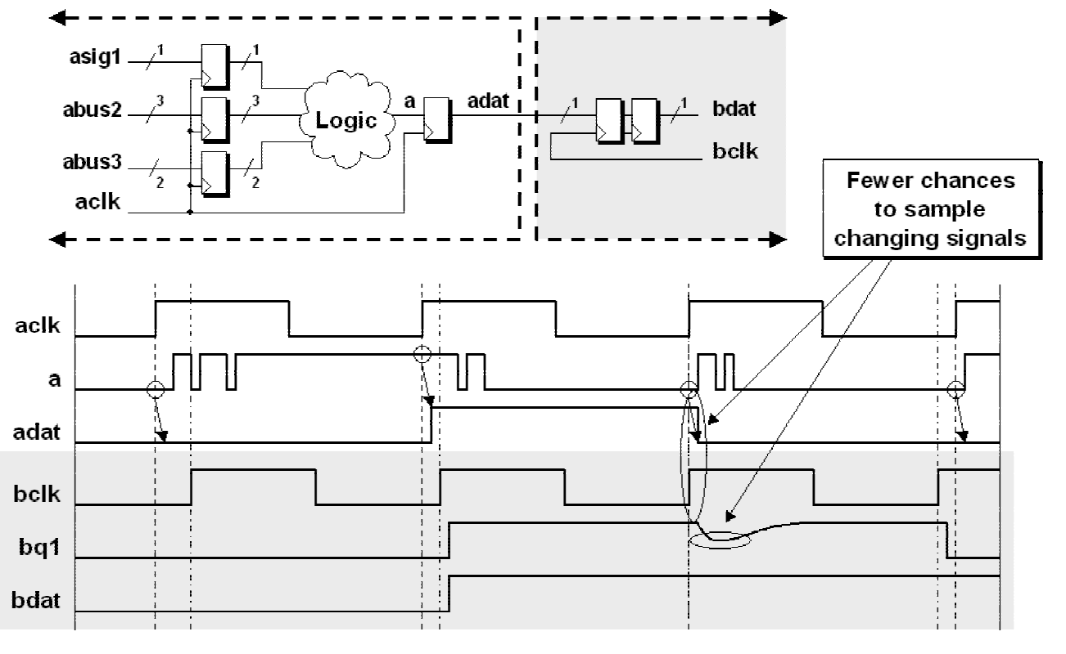
Figure 7 - Registered signals sent across a CDC boundary
In Figure 7, the aclk logic settles and sets up on the adat flip-flop before being passed into the
bclk domain. The adat flip-flop filters out the combinational settling on the flip-flop input (a)
and passes a clean signal to the bclk logic.

4.0 Synchronizing fast signals into slow clock domains
As discussed in section 3.1, if a CDC signal cannot be skipped when passed between clock
domains, it is important to consider signal widths or synchronization techniques when they are
passed between clock domains.
One issue associated with synchronizers is the possibility that a signal from a sending clock
domain might change values twice before it can be sampled, or might be too close to the
sampling edges of a slower clock domain. This possibility must be considered any time signals
are sent from one clock domain to another and a determination must be made whether missed
signals are or are not a problem for the design in question.
When missed samples are not allowed, there are two general approaches to the problem:
(1) An open-loop solution to ensure that signals are captured without acknowledgment.
(2) A closed-loop solution that requires acknowledgement of receipt of the signal that crosses a
CDC boundary.
Both solutions are discussed in this section.

4.1 Requirement for reliable signal passing between clock domains
Synchronizing slower control signals into a faster clock domain is generally not a problem if the
faster clock domain is 1.5X the frequency (or more) of the slower clock domain, since the faster
clock signal will sample the slower CDC signal one or more times. Recognizing that sampling
slower signals into faster clock domains causes fewer potential problems than sampling faster
signals into slower clock domains, a designer might to take advantage of this fact by using simple
two flip-flop synchronizers to pass single CDC signals between clock domains.

4.1.1 The "three edge" requirement
Mark Litterick[4] noted that when passing one CDC signal between clock domains through a
two-flip-flop synchronizer, the CDC signal must be wider than 1-1/2 times the cycle width of the
receiving domain clock period. Littereick described this requirement as "input data values must
be stable for three destination clock edges."
For exceptionally long source and destination clock frequencies, this requirement could probably
be safely relaxed to 1-1/4 times the cycle time of the receiving clock domain or less, but the
"three edge" guideline is the safest initial design condition, and is easier to prove through the use
of SystemVerilog assertions than to dynamically measure a fractional width of a CDC signal
during simulation.
The "three edge" requirement actually applies to both open-loop and closed-loop solutions, but
implementations of the closed-loop solution automatically ensure that at least three edges are
detected for all CDC signals.

4.2 Problem - passing a fast CDC pulse
Consider the severely flawed condition where the sending clock domain has a higher frequency
than the receiving clock domain and that a CDC pulse is only one cycle wide in the sending clock
domain. If the CDC signal is only pulsed for one fast-clock cycle, the CDC signal could go high
and low between the rising edges of a slower clock and not be captured into the slower clock
domain as shown in Figure 8.
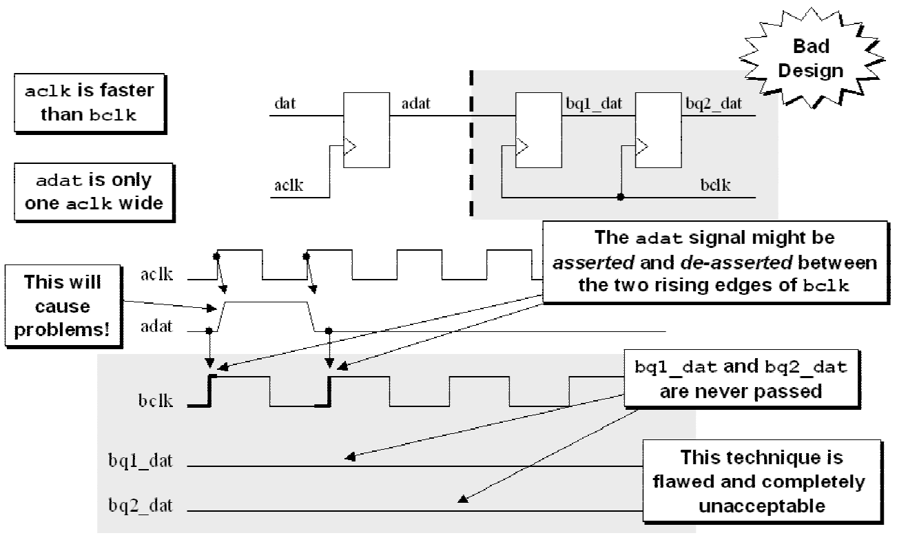
Figure 8 - Short CDC signal pulse missed during synchronization

4.3 Problem - sampling a long CDC pulse - but not long enough!
Consider the somewhat non-intuitive and flawed condition where the sending clock domain
sends a pulse to the receiving clock domain that is slightly wider than the period of the receiving
clock frequency. Under most conditions, the signal will be sampled and passed, but there is the
small but real chance that the CDC pulse will change too close to the two rising clock edges of
the receiving clock domain and thereby violate the setup time on the first clock edge and violate
the hold time of the second clock edge and not form the anticipated pulse. This possible failure is
shown in Figure 9.
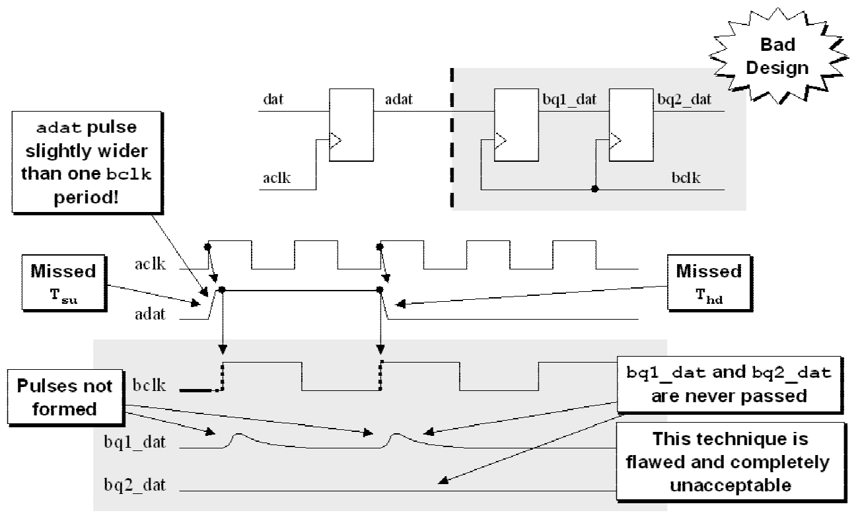
Figure 9 - Marginal CDC pulse that violates the destination setup and hold times

4.4 Open-loop solution - sampling signals with synchronizers
One potential solution to this problem is to assert CDC signals for a period of time that exceeds
the cycle time of the sampling clock as shown in Figure 10. As discussed in section 4.1.1, the
minimum pulse width is 1.5X the period of the receiving clock frequency. The assumption is that
the CDC signal will be sampled at least once and possibly twice by the receiver clock.
Open-loop sampling can be used when relative clock frequencies are fixed and properly
analyzed.
Advantage: the Open-loop solution is the fastest way to pass signals across CDC boundaries that
does not require acknowledgement of the received signal.
Disadvantage: the largest potential problem related to an open-loop solution is that another
engineer might mistake the solution for a general purpose solution, or the design requirements
might change and an engineer might fail to re-analyze the original open loop solution. This
problem can be minimized by adding a SystemVerilog Assertion to the model to detect if the
input pulse ever fails to exceed the "three edges" design requirement.
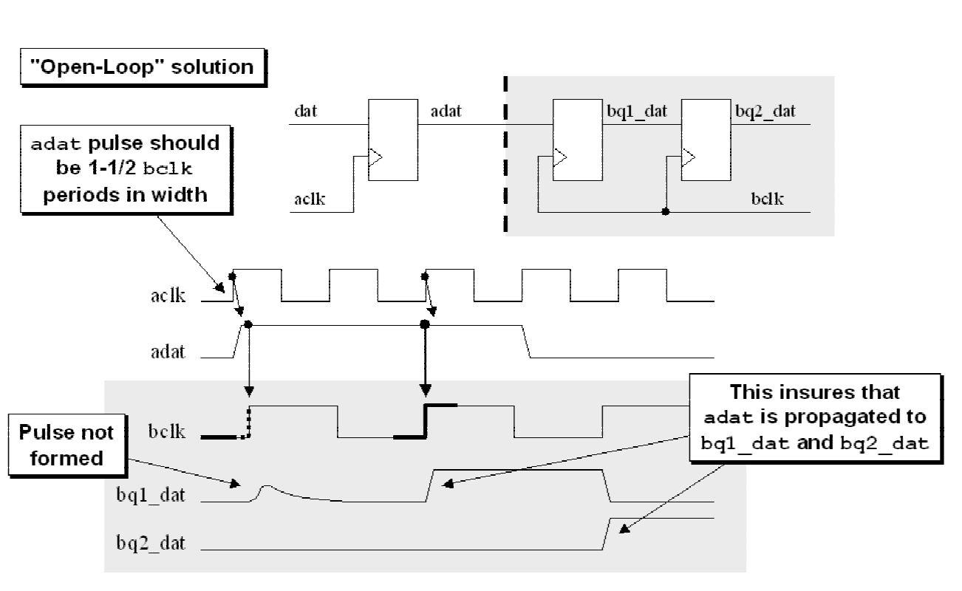
Figure 10 - Lengthened pulse to guarantee that the control signal will be sampled

4.5 Closed loop solution - sampling signals with synchronizers
A second potential solution to this problem is to send an enabling control signal, synchronize it
into the new clock domain and then pass the synchronized signal back through another
synchronizer to the sending clock domain as an acknowledge signal.
Advantage: synchronizing a feedback signal is a very safe technique to acknowledge that the
first control signal was recognized and sampled into the new clock domain.
Disadvantage: there is potentially considerable delay associated with synchronizing control
signals in both directions before allowing the control signal to change.
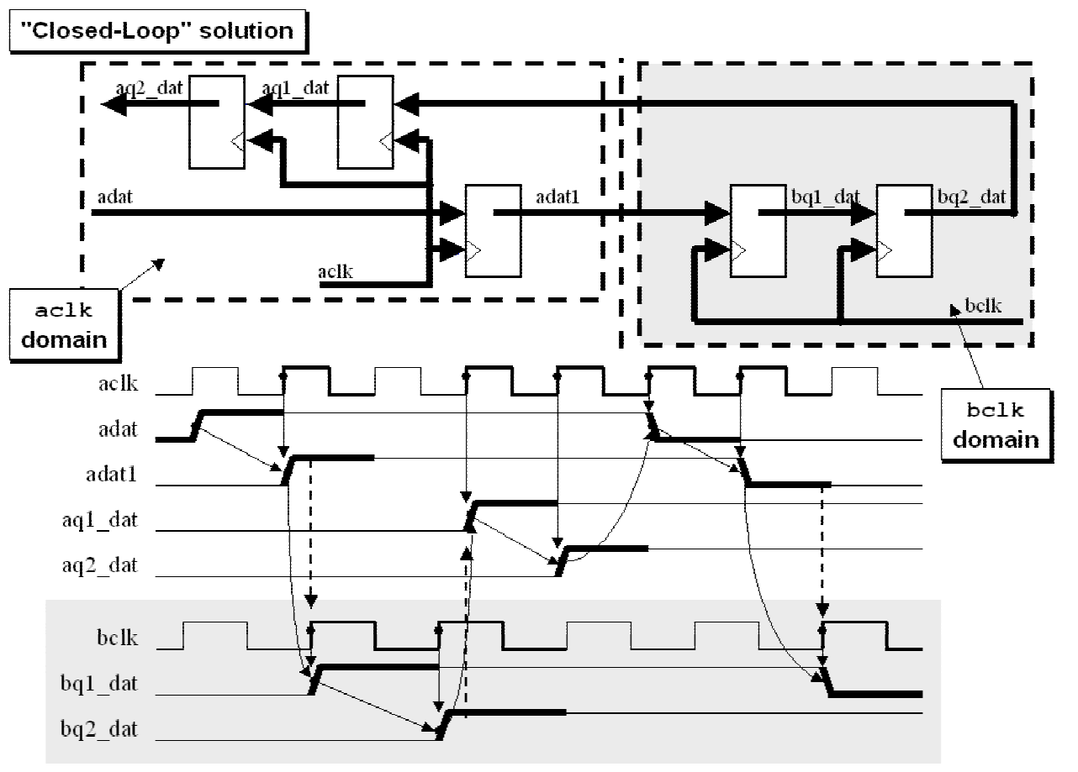
Figure 11 - Signal with feedback to acknowledge receipt

5.0 Passing multiple signals between clock domains
When passing multiple signals between clock domains, simple synchronizers do not guarantee
safe delivery of the data.
A frequent mistake made by engineers when working on multi-clock designs is passing multiple
CDC bits required in the same transaction from one clock domain to another and overlooking the
importance of the synchronized sampling of the CDC bits.
The problem is that multiple signals that are synchronized to one clock will experience small
data changing skews that can occasionally be sampled on different rising clock edges in a second
clock domain. Even if we could perfectly control and match the trace lengths of the multiple
signals, differences in rise and fall times as well as process variations across a die could
introduce enough skew to cause sampling failures on otherwise carefully matched traces.
Multi-bit CDC strategies must be employed to avoid skewed sampling of the multi-bit value.

5.1 Multi-bit CDC strategies
To avoid multi-bit CDC skewed sampling scenarios, I have classified multi-bit CDC strategies
into three main categories:
(1) Multi-bit signal consolidation. Where possible, consolidate multiple CDC bits into 1bit CDC
signals.
(2) Multi-cycle path formulations. Use a synchronized load signal to safely pass multiple CDC
bits.
(3) Pass multiple CDC bits using gray codes.
Each of these strategies is detailed in the remainder of this section.

5.2 Multi-bit signal consolidation
Where possible, consolidate multiple CDC signals into a 1bit CDC signal. Ask yourself the
question, do I really need multiple bits to control logic across a CDC boundary?
Simply using synchronizers on all of the CDC bits is not always good enough as will be shown in
the following examples.
If the order or alignment of the control signals is significant, care must be taken to correctly pass
the signals into the new clock domain. All of the examples shown in this section are overly
simplistic but they closely mimic situations that often arise in real designs.

5.3 Problem - Two simultaneously required control signals.
In the simple example shown in Figure 12, a register in the receiving clock domain requires both
a load signal and an enable signal in order to load a data value into the register. If both the load
and enable signals are driven on the same sending clock edge, there is a chance that a small skew
between the control signals could cause the two signals to be synchronized into different clock
cycles within the receiving clock domain. Under these conditions, the data would not be loaded
into the register.
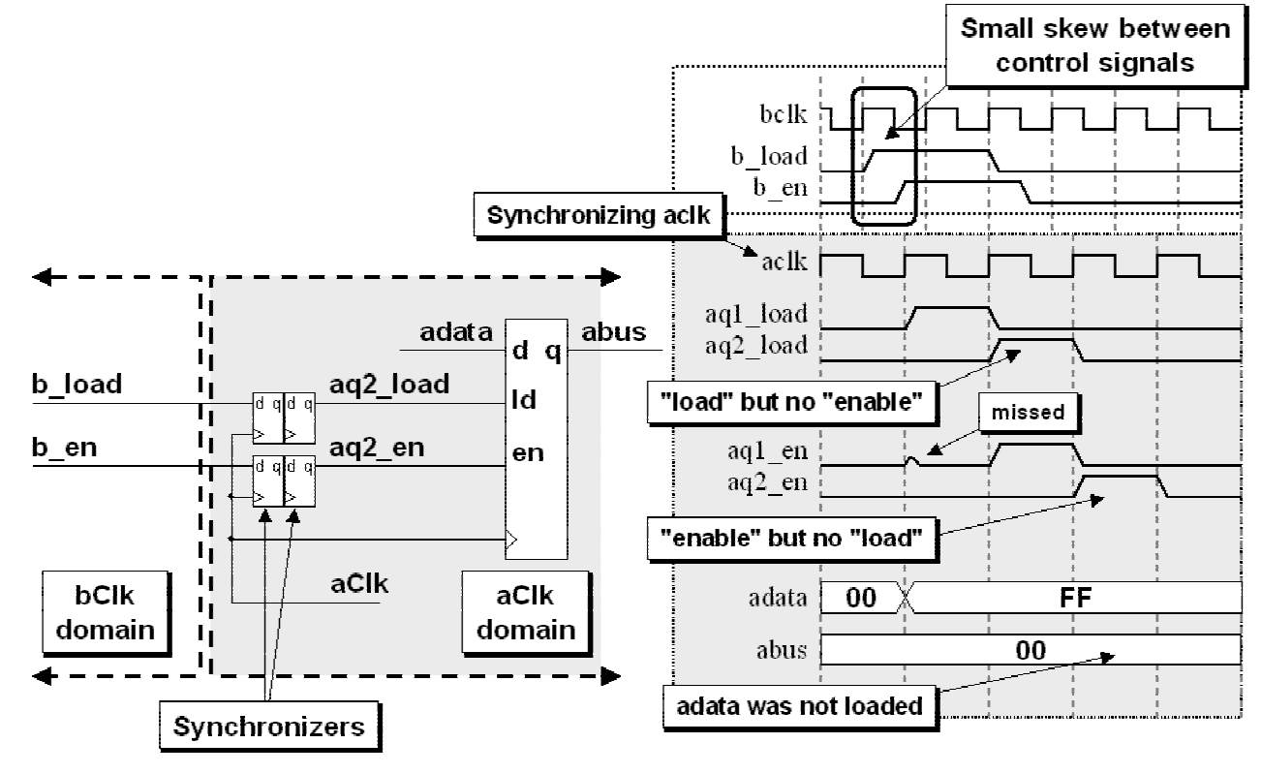
Figure 12 - Problem - Passing multiple control signals between clock domains

5.3.1 Solution - Consolidation
The solution to the problem in section 5.3 is simple, consolidate the control signals. As shown in
Figure 13, drive both the load and enable register input signals in the receiving clock domain
from just one load-enable signal. Consolidation will remove the potential of two control signals
arriving shifted in time.
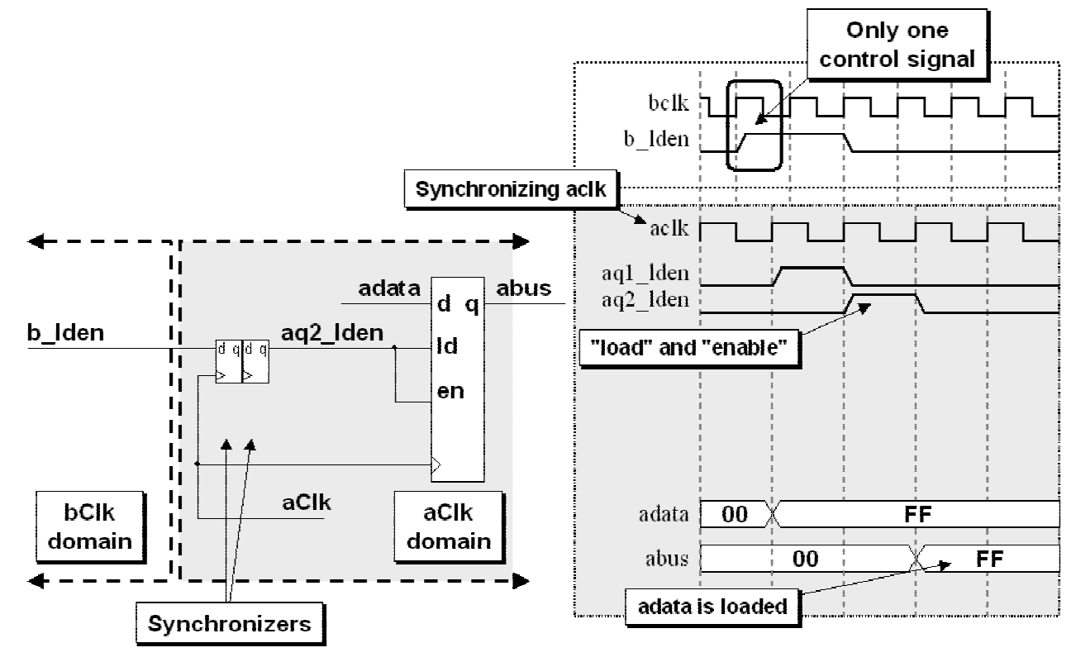
Figure 13 - Solution - Consolidating control signals before passing between clock domains

5.4 Problem - Two phase-shifted sequencing control signals.
The diagram in Figure 14, shows two enable signals, aen1 and aen2, that are sequentially driven
from a sending clock domain into the receiving clock domain to control the enable inputs of
pipelined data registers. The problem is that in the first clock domain, the aen1 control signal
might terminate slightly before the aen2 control signal is generated, and the rising edge of the
receiving clock might occur in the slight gap between the aen1 and aen2 control signal pulses,
causing a one-cycle gap to form in the enable control-signal chain in the receiving clock domain.
This would cause the a2 data value to be missed by the second register.
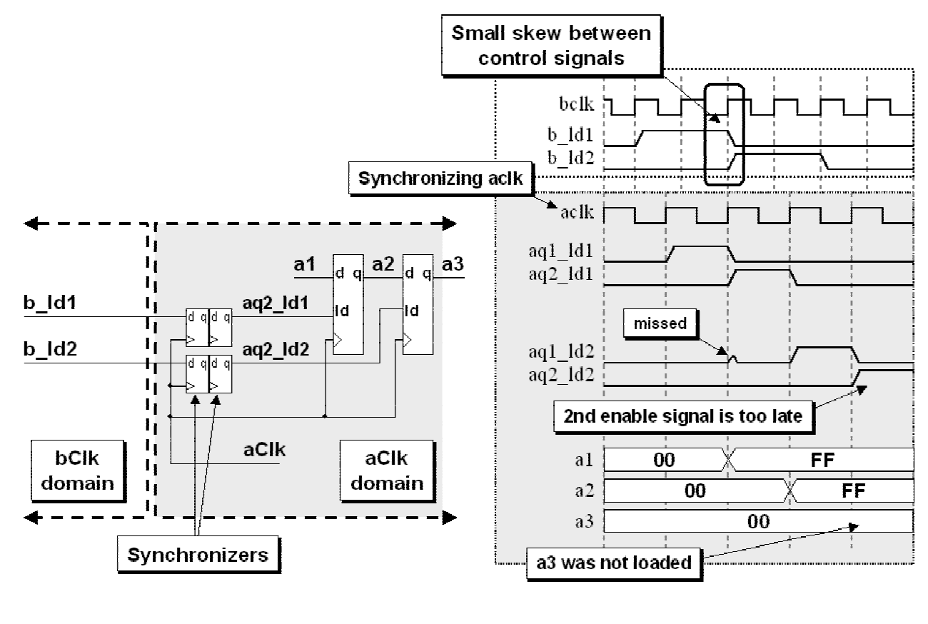
Figure 14 - Problem - Passing sequential control signals between clock domains

5.4.1 Solution - consolidation and an extra flip-flop
The solution to this problem, as shown in Figure 15, is to send only one control signal into the
receiving clock domain and generate the second phase-shifted pipelined enable signal within the
receiving clock domain.
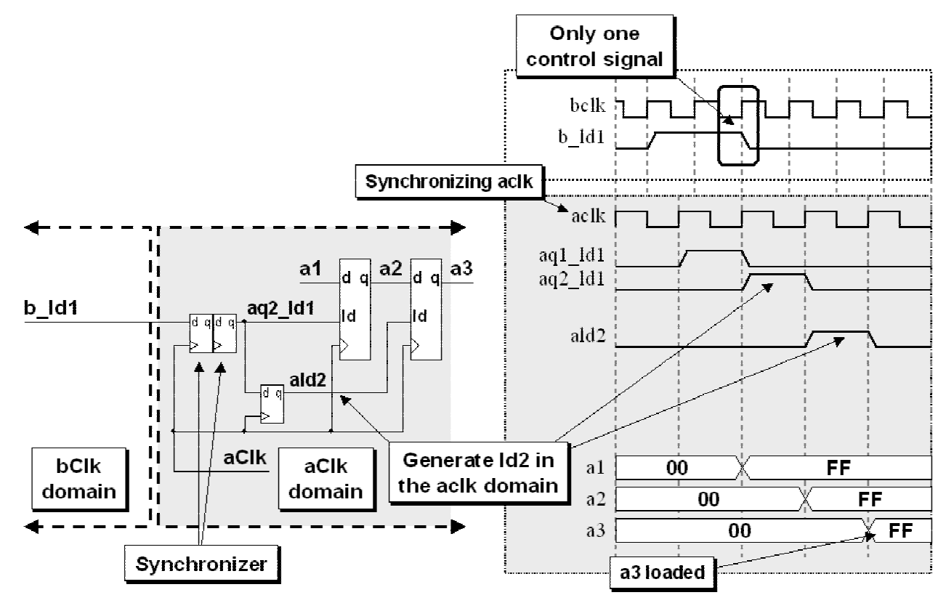
Figure 15 - Solution - Logic to generate proper sequencing signals in the new clock domains

5.5 Problem - Multiple CDC signals
The diagram in Figure 16 shows two encoded control signals being passed between clock
domains. If the two encoded signals are slightly skewed when sampled, an erroneous decoded
output could be generated for one clock period in the receiving clock domain.
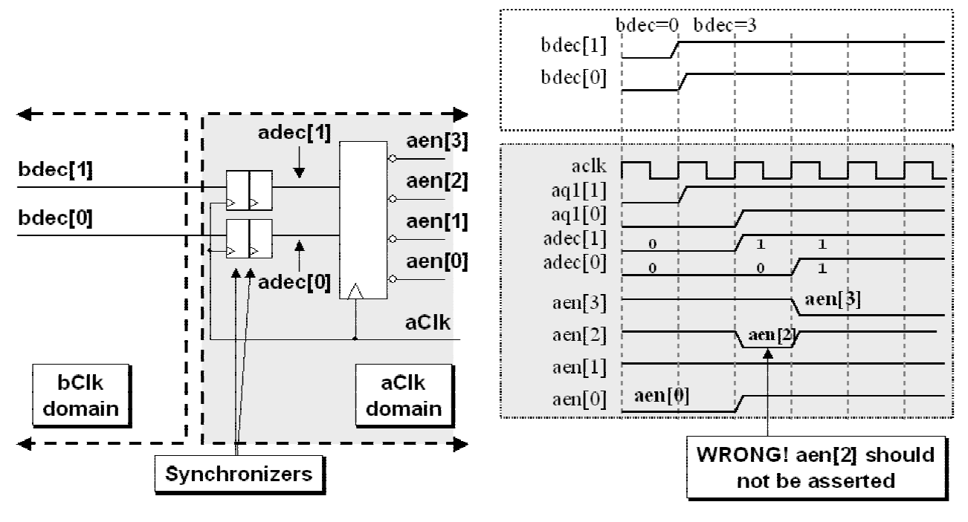
Figure 16 - Problem - Encoded control signals passed between clock domains

5.5.1 Solutions for passing multiple CDC signals
Multi-Cycle Path (MCP) formulations and FIFO techniques can be used to address problems
related to passing multiple CDC signals. A description and definition of an MCP formulation is
given in section 5.6
There are at least two Multi-Cycle Path (MCP) formulations that can be used to fix this problem:
(1) Closed-loop - MCP formulation with feedback.
(2) Closed-loop - MCP formulation with acknowledge feedback.
The MCP formulation implementation techniques are described starting in the next section.
There are also at least two FIFO strategies that act as closed loop solutions to this problem:
(1) Asynchronous FIFO implementation.
(2) 2-deep FIFO implementation.
The FIFO implementation techniques are described starting in section 5.8.
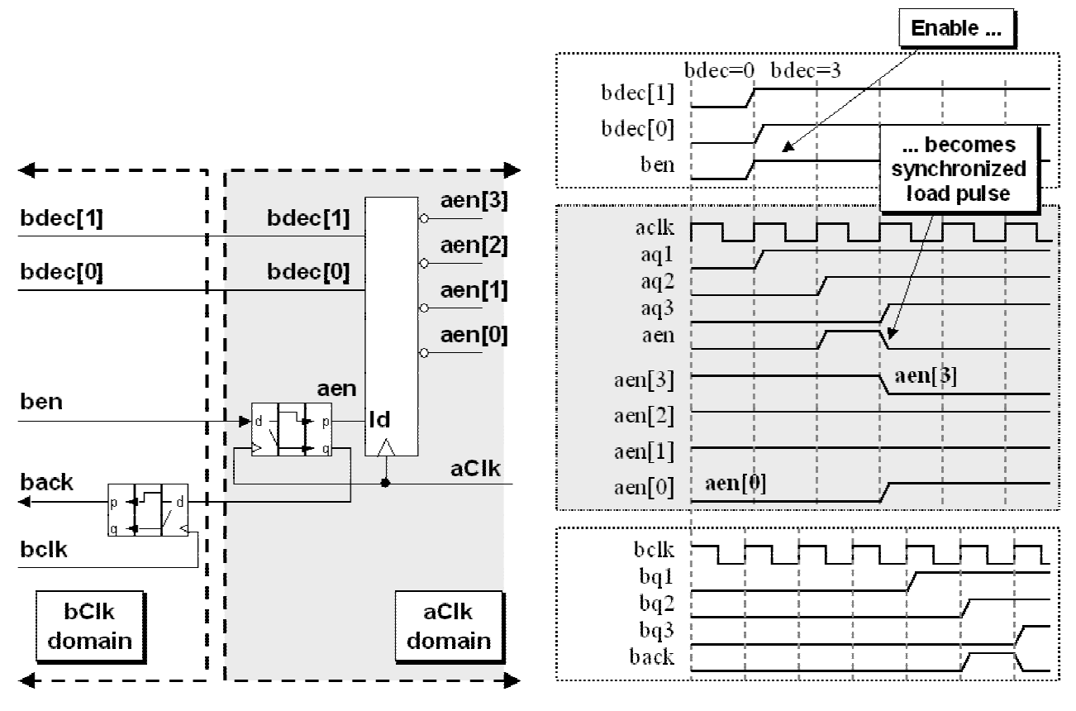
Figure 17 - Logic to pass a synchronized enable pulse between clock domains

5.6 Multi-Cycle Path (MCP) formulation
Using an MCP formulation is a common technique for safely passing multiple CDC signals.
An MCP formulation refers to sending unsynchronized data to a receiving clock domain paired
with a synchronized control signal. The data and control signals are sent simultaneously allowing
the data to setup on the inputs of the destination register while the control signal is synchronized
for two receiving clock cycles before it arrives at the load input of the destination register.
Advantages:
(1) The sending clock domain is not required to calculate the appropriate pulse width to send
between clock domains.
(2) The sending clock domain is only required to toggle an enable into the receiving clock
domain to indicate that data has been passed and is ready to be loaded. The enable signal is
not required to return to its initial logic level.
This strategy passes multiple CDC signals without synchronization, and simultaneously passes a
synchronized enable signal to the receiving clock domain. The receiving clock domain is not
allowed to sample the multi-bit CDC signals until the synchronized enable passes through
synchronization and arrives at the receiving register.
This strategy is called a Multi-Cycle Path Formulation[8] due to the fact that the unsynchronized
data word is passed directly to the receiving clock domain and held for multiple receiving clock
cycles, allowing an enable signal to be synchronized and recognized into the receiving clock
domain before permitting the unsynchronized data word to change.
Because the unsynchronized data is passed and held stable for multiple clock cycles before being
sampled, there is no danger that the sampled value will go metastable.

5.6.1 MCP formulation using a synchronized enable pulse
Perhaps the most common method to pass a synchronized enable signal between clock domains
is to employ a toggling enable signal that is passed to a synchronized pulse generator to indicate
that the unsynchronized multi-cycle data word can be captured on the next receiving clock edge
as shown in Figure 18.
A key feature of this synchronized enable pulse generation is that the polarity of the input signal
does not matter. In Figure 18, the d-input is toggled high in cycle 1 and by cycle 4 a high signal
has propagated through the three synchronizing flip-flops. In cycle 3 the outputs of the q2 and q3
flip-flops have a different polarity causing the synchronized enable pulse to form on the output of
the exclusive-or gate in that same cycle. Similarly, the d-input is toggled low in cycle 7 and by
cycle 10 a high signal has propagated through the three synchronizing flip-flops. And again in
cycle 9 the outputs of the q2 and q3 flip-flops have a different polarity causing the synchronized
enable pulse to form on the output of the exclusive-or gate.
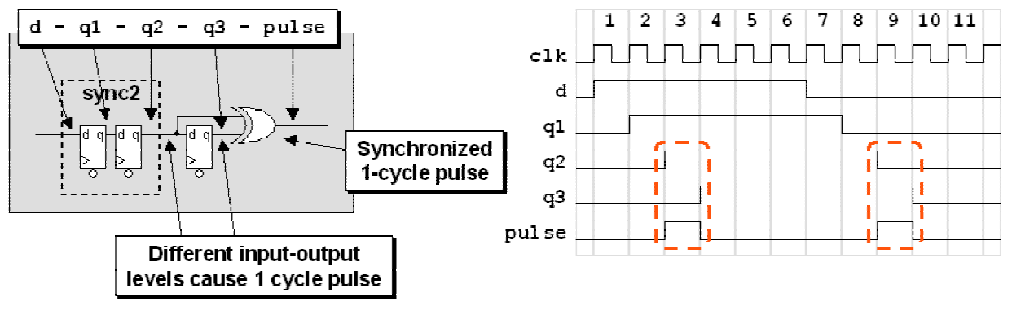
Figure 18 - Synchronized pulse generation logic
Since all of the MCP formulations described in section 5.0 use the synchronized enable pulse
generation circuit, it was deemed useful to create and use a smaller equivalent symbol to
represent the synchronized enable pulse generation circuit. The equivalent symbol is shown in
Figure 19.
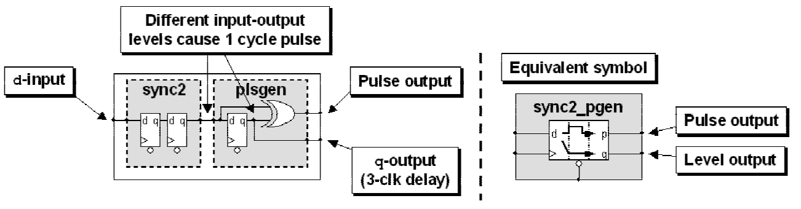
Figure 19 - Synchronized enable pulse generation logic and equivalent symbol
In addition to generating a pulse off of any d-input polarity, the synchronized enable pulse
generation circuit also has a q-output that follows the d-input delayed by three clock cycles. The
q-output is frequently used as a feedback signal and passed as an acknowledge signal through
another synchronized enable pulse generation circuit in the sending clock domain.
Figure 20 shows a typical send-receive toggle-pulse generation design.
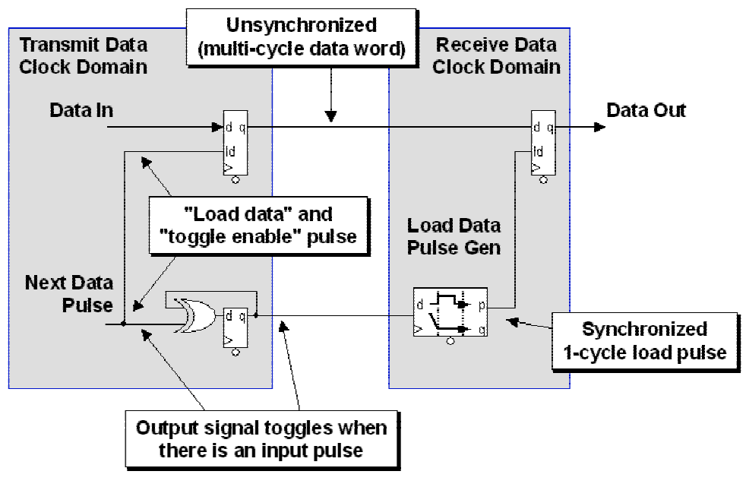
Figure 20 - Multi-Cycle Path (MCP ) formulation toggle-pulse generation
Using this technique, it is required that the receiving clock domain have logic in place to capture
the data when the pulse is detected, because the pulse will only be valid for one receiving clock
cycle per multi-cycle data word.

5.6.2 Closed-loop - MCP formulation with feedback
An important technique when using an MCP formulation is to pass the enable signal back to the
sending clock domain as an acknowledge signal as shown in Figure 21.
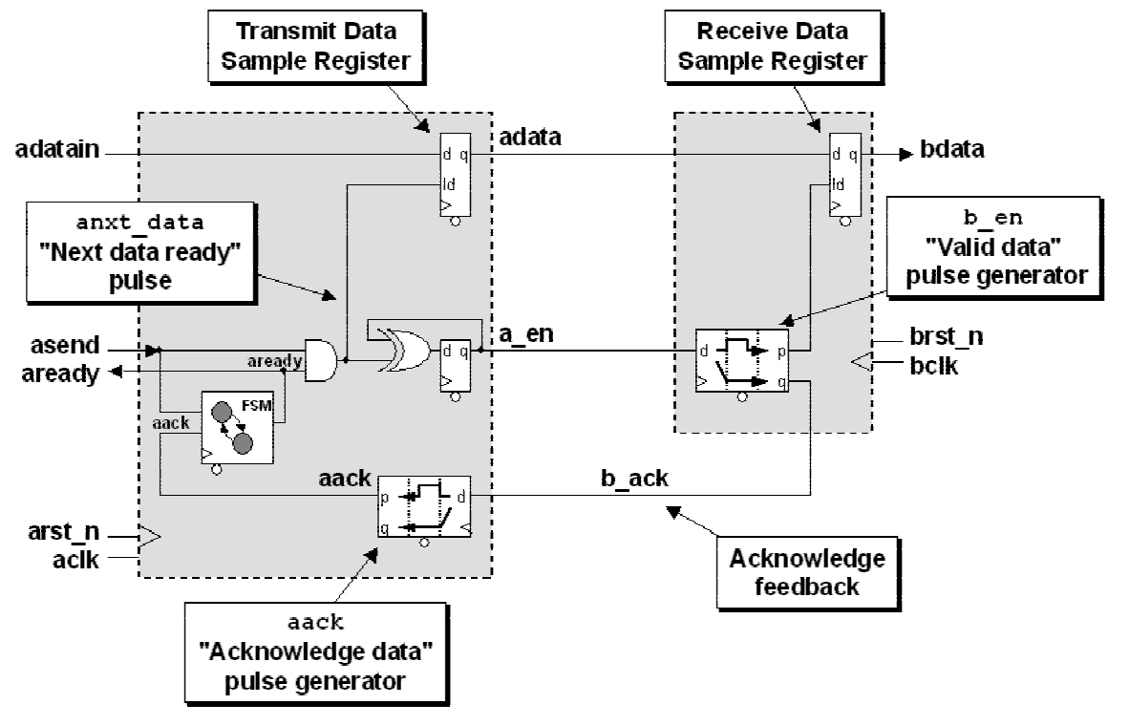
Figure 21 - Multi-Cycle Path (MCP ) formulation toggle-pulse generation with acknowledge
For the example in Figure 21, the acknowledge feedback signal (b_ack) generates an
acknowledge pulse (aack) that is used as an input to a small READY-BUSY, 1-state FSM block
that generates a ready signal (aready) to indicate that it is now safe to change the data input
(adatain) value again. Once the aready signal goes high, the sender is free to send new data
(adatain) and the accompanying asend control signal.
This is an automatic feedback path that assumes that the receiving clock domain will always be
ready for the next data word synchronized through an MCP formulation.

5.6.3 Closed-loop - MCP formulation with acknowledge feedback
A fully responsive variation of the technique described in section 5.6.2 uses an MCP formulation
is to pass the enable signal back to the sending clock domain as an acknowledge signal only after
the receiving clock domain acknowledges receipt of the data with a bload pulse as shown in
Figure 22.
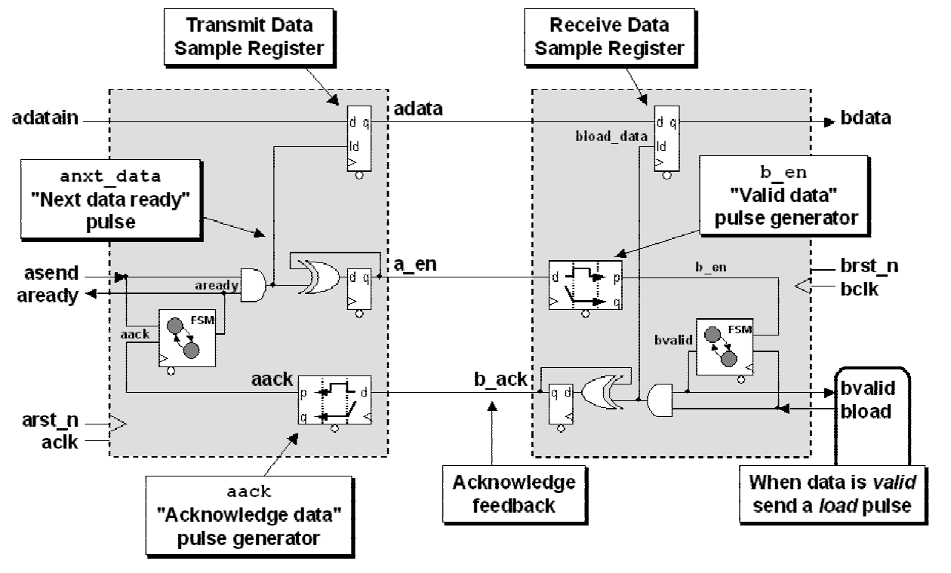
Figure 22 - Multi-Cycle Path (MCP ) formulation toggle-pulse generation with ready-ack
For the example in Figure 22, the receiving clock domain has a small WAIT-READY, 1-state FSM
that sends a valid signal (bvalid) to the receiving logic when data is valid on the input to the
data register. The data is not actually loaded until the receiving logic acknowledges that the data
should be loaded by asserting the bload signal. There is no feedback to the sending clock
domain until the data has been loaded, then the b_ack signal is sent back the same as the MCP
formulation with automatic feedback.
This is an feedback path requires action on the part of the receiving clock domain before data is
captured and feedback is sent.

5.7 Synchronizing counters
As mentioned earlier, when passing multiple signals between clock domains, an important
question to ask is, do I need to sample every value of a signal that is passed from one clock
domain to another? With counters, the answer is frequently, no!
Reference [1] details FIFO design techniques where gray code counters are sampled between
clock domains and intermediate gray count values are often missed. For this FIFO design, the
greater consideration is to make sure that the counters cannot overrun their boundaries, which
could cause missed full and empty flag detection. Even though the sampled gray count values
between clock domains are often missed, the design is robust and all important gray count values
are appropriately sampled. See [1] for details.
Since a valid design might be allowed to skip some count value samples, can any counter be used
to pass count values across a CDC boundary? The answer is no.

5.7.1 Binary counters
One characteristic of binary counters is that half of all sequential binary incrementing operations
require that two or more counter bits must change. Trying to synchronize a binary counter across
a CDC boundary is the same as trying to synchronize multiple CDC signals into a new clock
domain. If a simple 4-bit binary counter changes from address 7 (binary 0111) to address 8
(binary 1000), all four counter bits will change at the same time. If a synchronizing clock edge
comes in the middle of this transition, it is possible that any 4-bit binary pattern could be sampled
and synchronized into the new clock domain as shown in Figure 23.
Binary Count
07 -> 08 possible binary transitions
Values
0 1 1 1 -> 1 0 0 0 (07->08)
0 1 1 1 -> 0 0 0 0 (07->00)
0 1 1 1 -> 0 0 0 1 (07->01)
0 1 1 1 -> 0 0 1 0 (07->02)
0 1 1 1 -> 0 0 1 1 (07->03)
0 1 1 1 -> 0 1 0 0 (07->04)
0 1 1 1 -> 0 1 0 1 (07->05)
0 1 1 1 -> 0 1 1 0 (07->06)
0 1 1 1 -> 0 1 1 1 (07->07)
0 1 1 1 -> 1 0 0 0 (07->08)
0 1 1 1 -> 1 0 0 1 (07->09)
0 1 1 1 -> 1 0 1 0 (07->10)
0 1 1 1 -> 1 0 1 1 (07->11)
0 1 1 1 -> 1 1 0 0 (07->12)
0 1 1 1 -> 1 1 0 1 (07->13)
0 1 1 1 -> 1 1 1 0 (07->14)
0 1 1 1 -> 1 1 1 1 (07->15)
00 0 0 0 0
01 0 0 0 1
02 0 0 1 0
03 0 0 1 1
04 0 1 0 0
05 0 1 0 1
06 0 1 1 0
07 0 1 1 1
08 1 0 0 0
09 1 0 0 1
10 1 0 1 0
11 1 0 1 1
12 1 1 0 0
13 1 1 0 1
14 1 1 1 0
15 1 1 1 1
Figure 23 - Binary count values sampled in mid-transition
In a FIFO design, the new synchronized binary value might trigger a false full or empty flag, or
even worse, it might not trigger a real full or empty flag causing data to be lost due to FIFO
overflow or causing invalid data to be read from the FIFO due to an attempt to read data when
the FIFO is really empty.

5.7.2 Gray codes
Gray codes are named after Frank Gray[4] and the safest counters that can be used in multi-clock
designs are Gray code counters. Gray codes only allow one bit to change for each clock
transition, eliminating the problem associated with trying to synchronize multiple changing CDC
bits across a clock domain.
Standard gray codes have very nice translation properties to convert gray-to-binary and back
again. Using these conversions, it is simple to design efficient gray code counters.

5.7.3 Gray-to-binary conversion
To convert a gray-code value to an equivalent binary-code value, using an n-bit gray code value
as an example, binary bit 0 is equal to the exclusive-or of gray code bit 0 exclusive-ored with all
other gray code bits from 1 to n. Binary bit 1 is equal gray code bit 1 exclusive-ored with all
other gray code bits from 2 to n, etc. The most significant binary bit is just equal to the most
significant gray code bit.
The equations for a sample 4-bit gray-to-binary conversion are shown in Figure 24.
bin[0] = gray[3] ^ gray[2] ^ gray[1] ^ gray[0];
bin[1] = gray[3] ^ gray[2] ^ gray[1];
bin[2] = gray[3] ^ gray[2];
bin[3] = gray[3];
Figure 24 - 4-bit gray-to-binary conversion equations
The easiest way to code a gray-to-binary converter is to code a for-loop and do an exclusive-or
reduction on a gray code vector with variable index range, where each time through the loop the
LSB of the index range increases until we are left with a simple assignment of bin[MSB] =
^gray[MSB:MSB] (just the 1-bit MSB of the gray code vector), as shown in Example 1.
module gray2bin_bad #(parameter SIZE = 4)
(output logic [SIZE-1:0] bin,
input logic [SIZE-1:0] gray);
// Syntax Error - variable index range
always_comb
for (int i=0; i<SIZE; i++)
bin[i] = ^(gray[SIZE-1:i]);
endmodule
Example 1 - Non-working but conceptually correct gray-to-binary SystemVerilog model
Unfortunately, Verilog and SystemVerilog do not permit part selects using a variable index range
so the code in Example 1, although conceptually correct, will not compile.
To address this issue, remember that an exclusive-or gate is really a programmable inverter. If
one input is tied high, the other input is inverted and passed to the output. Similarly, if one input
is tied low, the other input is passed to the output without inversion (no change from input to
output).
Taking advantage of the fact that any added exclusive-or operation that involves a 0-input does
not change the outcome of the operation, the way to approach of a gray-to-binary conversion is to
exclusive-or the significant gray-code bits with padded 0's as shown in Figure 25.
bin[0] = gray[3] ^ gray[2] ^ gray[1] ^ gray[0] ; // gray>>0
bin[1] = 1'b0 ^ gray[3] ^ gray[2] ^ gray[1] ; // gray>>1
bin[2] = 1'b0 ^ 1'b0 ^ gray[3] ^ gray[2] ; // gray>>2
bin[3] = 1'b0 ^ 1'b0 ^ 1'b0 ^ gray[3] ; // gray>>3
Figure 25 - 4-bit gray-to-binary conversion equations - 2nd method
The corresponding parameterized SystemVerilog model for this simplified algorithm is shown in
Example 2. This example is syntactically correct, will compile and does work.
module gray2bin #(parameter SIZE = 4)
(output logic [SIZE-1:0] bin,
input logic [SIZE-1:0] gray);
always_comb
for (int i=0; i<SIZE; i++)
bin[i] = ^(gray>>i);
endmodule
Example 2 - Parameterized and correct gray-to-binary SystemVerilog model
What happens to all of the extra exclusive-or operations with inputs tied to 0? Synthesis tools
recognize that exclusive-or gates with a constant-0 on one input can be optimized away to infer a
very efficient implementation of the design.

5.7.4 Binary-to-gray conversion
To convert a binary value to an equivalent gray-code value, using an n-bit binary value as an
example, gray-code bit 0 is equal to the exclusive-or of binary bits 0 and 1. Gray-code bit 1 is
equal to the exclusive-or of binary bits 1 and 2, etc. The most significant gray-code bit is just
equal to the most significant binary bit.
The equations for a sample 4-bit binary-to-gray conversion are shown in Figure 26.
gray[0] = bin[0] ^ bin[1];
gray[1] = bin[1] ^ bin[2];
gray[2] = bin[2] ^ bin[3];
gray[3] = bin[3] ^ 1'b0 ; // same as gray[3] = bin[3];
Figure 26 - 4-bit binary-to-gray conversion equations
The easiest way to code a binary-to-gray converter is to code a simple continuous assignment that
performs a bit-wise exclusive-or operation between the binary vector and a right-shifted version
of the same binary vector as shown in
Example 3. This example is syntactically correct, will compile and does work.
module bin2gray #(parameter SIZE = 4)
(output logic [SIZE-1:0] gray,
input logic [SIZE-1:0] bin);
assign gray = (bin>>1) ^ bin;
endmodule
Example 3 - Parameterized binary-to-gray SystemVerilog model

5.7.5 Gray code counter style #1
We can build a gray code counter by using the conversions that were shown in sections 5.7.3 and
5.7.4. For any gray code counter, it is important to remember that the gray-output must be
registered to eliminate any combinational settling in the design.
The SystemVerilog code for gray-code counter style #1 incorporates a gray-to-binary converter, a
binary-to-gray converter and increments the binary value between conversions as shown in
Figure 27.
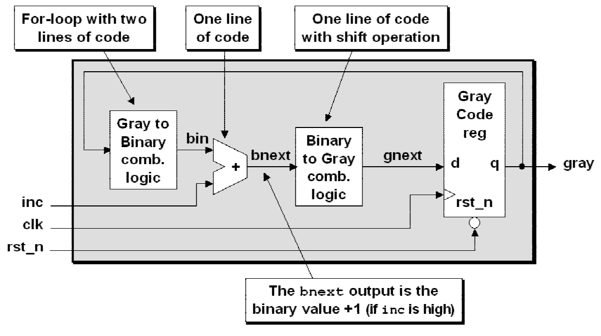
Figure 27 - Gray code counter style #1 - only one gray code register
The corresponding parameterized SystemVerilog model for the gray-code counter style #1 is
shown in Example 4.
module graycntr #(parameter SIZE = 5)
(output logic [SIZE-1:0] gray,
input logic clk, inc, rst_n);
logic [SIZE-1:0] gnext, bnext, bin;
always_ff @(posedge clk or negedge rst_n)
if (!rst_n) gray <= '0;
else gray <= gnext;
always_comb begin
for (int i=0; i<SIZE; i++)
bin[i] = ^(gray>>i);
bnext = bin + inc;
gnext = (bnext>>1) ^ bnext;
end
endmodule
Example 4 - Parameterized gray-code counter SystemVerilog model

5.7.6 Gray code counter style #2
We can build the second style of gray code counter by using just the binary-to-gray conversions
that were shown in section 5.7.4. This gray code counter actually both a binary count register and
a gray code count register.
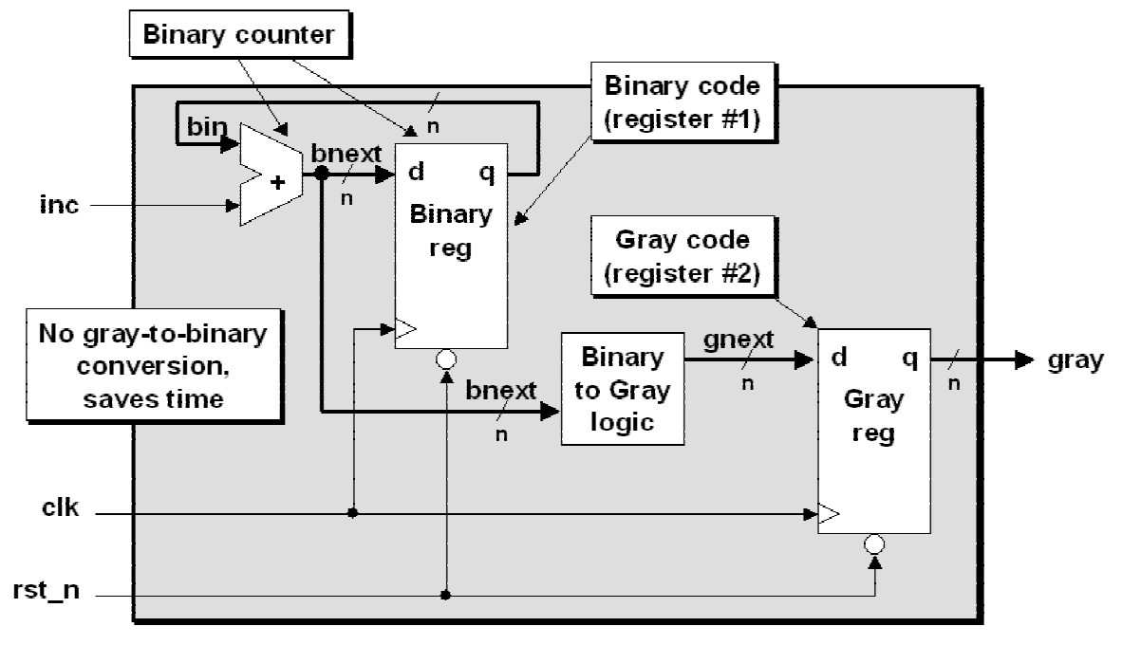
Figure 28 - Gray code counter style #2 - binary register and gray code register
The SystemVerilog code for gray-code counter style #2 incorporates a binary counter to eliminate
the need for the gray-to-binary conversion, and uses the next binary count value to do the binary-
to-gray conversion that is then registered into the gray code register. This style uses twice as
many flip-flops but a shorter combinational logic path to generate the next gray code value,
which makes this implementation faster than gray code counter style #1. The block diagram for
gray code counter style #2 is shown in Figure 28,
The corresponding parameterized SystemVerilog model for the gray-code counter style #2 is
shown in Example 5.
module graycntr #(parameter SIZE = 5)
(output logic [SIZE-1:0] gray,
input logic clk, full, inc, rst_n);
logic [SIZE-1:0] gnext, bnext, bin;
always_ff @(posedge clk or negedge rst_n)
if (!wrst_n) {bin, gray} <= '0;
else {bin, gray} <= {bnext, gnext};
assign bnext = !full ? bin + inc : bin;
assign gnext = (bnext>>1) ^ bnext;
endmodule
Example 5 - Parameterized gray-code counter with binary counter

5.8 Additional multi-bit CDC techniques
In addition to the MCP formulation techniques described in earlier sections, I have found a
number of engineers that use standard FIFOs to pass data and control signals between clock
domains.
There are at least two interesting FIFO implementation strategies that can be used to address
multi-bit CDC signal integrity:
(1) Asynchronous FIFO implementations.
(2) 2-deep FIFO implementation.

5.8.1 Multi-bit CDC signal passing using asynchronous FIFOS
Passing multiple bits, whether data bits or control bits, can be done through an asynchronous
FIFO. An asynchronous FIFO is a shared memory or register buffer where data is inserted from
the write clock domain and data is removed from the read clock domain. Since both sender and
receiver operate within their own respective clock domains, using a dual-port buffer, such as a
FIFO, is a safe way to pass multi-bit values between clock domains.
A standard asynchronous FIFO device allows multiple data or control words to be inserted as
long as the FIFO is not full, and the receiver and then extract multiple data or control words
when convenient as long as the FIFO is not empty.
Most of the hard work in a FIFO design is done through the synchronization of gray code
counters and a proven FIFO design technique is described in [1].

5.8.2 Multi-bit CDC signal passing using 1-deep / 2-register FIFO synchronizer
Another interesting variation on passing multiple control and data bits across CDC boundaries
involves the use of a 1-deep two register FIFO as shown in Figure 29.
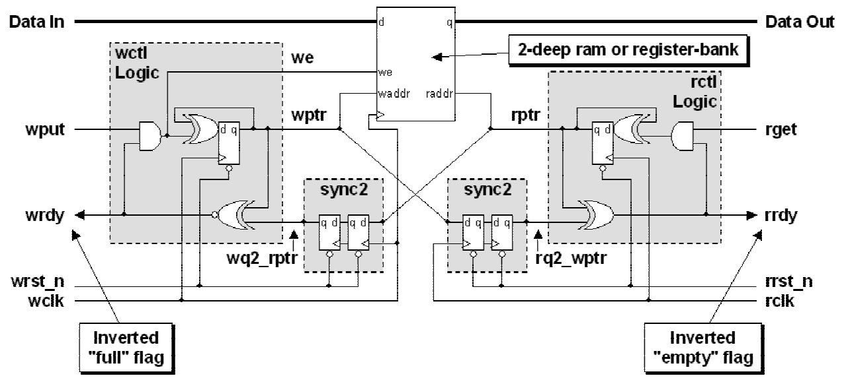
Figure 29 - 1-deep / 2-register FIFO synchronizer block diagram
This 1-deep two register FIFO has a number of interesting characteristics. Since the FIFO is built
using only two registers or a 2-deep dual port RAM, the gray code counters used to detect full
and empty are simple toggle flip-flops, which is really nothing more than 1-bit binary counters
(remember, the MSB of a standard gray code is the same as the MSB of a binary code).
On reset, both pointers are cleared and the FIFO is empty and hence the FIFO is not full. We use
the inverted not-full condition to indicate that the FIFO is ready to receive a data or control word
(wrdy is high). After a data or control word is put into the FIFO (using wput), the wptr toggles
and the FIFO becomes full, or in other words, the wrdy signal goes low, which also disables the
ability to toggle the wptr and therefore also disables the ability to put another word into the 2-
register FIFO until the first word is removed from the FIFO by the receiving clock-domain logic.
What is especially interesting about this design is that the wptr is now pointing to the second
location in the 2-register FIFO, so when the FIFO does again become ready (when wrdy is high),
the wptr is already pointing to the next location to write.
The same concept is replicated on receiving side of the FIFO. When a data or control word is
written into the FIFO, the FIFO becomes not empty. We use the inverted not-empty condition to
indicate that the FIFO is has a data or control word that is ready to be received (rrdy is high).
By using two registers to store the multi-bit CDC values, we are able to remove one clock cycle
from the send MCP formulation and another cycle from the acknowledge feedback path.

6.0 Naming conventions & design partitioning
Naming conventions help to ensure good team communication and also facilitate the use of
scripting languages to gather and group all signals in a design that are associated with a particular
clock. Good design partitioning can significantly reduce the effort to synthesize and verify the
timing of a multi-clock design. Recommended naming conventions and design partitioning are
discussed in this section.
There are two approaches to address potential CDC problems: (1) verify that the design meets
qualified CDC rules, (2) avoid the problem. Both approaches are valuable and should be used to
ensure an error-free design.
The first approach, verification of CDC design rules, typically requires the use of special tools to
check the design for possible CDC violations. When I wrote my first paper on multi-clock design
in 2001, I was unaware of any tool on the market that performed checking of CDC rules. Today
there are a number of companies that provide such tools (see [11] for a list of companies and
tools in the CDC verification space).
The second approach, avoid the problem, can be done by employing a few good coding
guidelines as outlined below.

6.1 Clock & signal naming conventions
A number of useful clock and signal naming conventions have been used by various design
teams.
Guideline: Use a clock naming convention to identify the clock source of every signal in a
design.
Reason: A naming convention helps all team members to identify the clock domain for every
signal in a design and also makes grouping of signals for timing analysis easier to do using
regular expression "wild-carding" from within a synthesis script.
One proven naming convention requires that a leading prefix character be used to identify the
various asynchronous clock domains. Examples included: uClk for the microprocessor clock,
vClk for the video clock and dClk for the display clock.
Each signal is then synchronized to one of the clock domains in the design and each signal-name
is labeled with a prefix character to identify the clock domain used to generate that signal. For
example, any signal that is generated by the uClk is labeled with a u-prefix in the signal name,
such as uaddr, udata, uwrite, etc. Any signal that is generated by the vClk is similarly
labeled with a v-prefix in the signal name, such as vdata, vhsync, vframe, etc. The same
signal naming convention is used for all signals generated by any of the other clocks in the
design.
Using this technique, any engineer on the design team can easily identify the clock-domain
source of any signal in the design and either use the signals directly or pass the signals through
proper synchronization so that the signals can be used within a new clock domain.
The exact naming convention is not important, but it is vital that every engineer on the project
agrees to adhere to the naming convention chosen by the team. A naming convention will
significantly contribute to the productivity of the design team.

6.1.1 Multi-clock / multi-source modules with no naming convention
If your team does not using any particular clock-oriented signal naming convention and if
modules are allowed to have multiple clock inputs, there is always the danger that the CDC
analysis tool might not be setup correctly and it is easy to miss bad CDC design practices.
Even if your team has access to good CDC analysis tools, I strongly recommend that you take a
few simple steps to make analysis and recognition of potential CDC design problems easier to
identify and debug.

6.2 Timing verification for each clock domain
To verify the timing of any design, one must verify the that timing is met for each clock domain
in a design. Although tools have improved over the past decade to help automate the analysis and
verification of signals in separate clock domains, it is still a good practice to approach multi-
clock design using good partitioning and naming conventions.
By partitioning a design to permit only one clock per module, static timing analysis becomes a
significantly easier task for each domain in the design.

6.3 Clock oriented design partitioning
Some of the simplest and best design partitioning methodologies are implemented using design
partitioning at clock boundaries.
Guideline: Only allow one clock per module[9].
Reason: Static timing analysis and creating synthesis scripts is more easily accomplished on
single-clock modules or groups of single-clock modules.
Exception: The top-level module that connects together the signals from all of the different
clock domains will naturally have all of the clocks as inputs to this module. Minimize your
multi-clock verification effort and only allow the top-module to have multiple clock inputs.
Guideline: Partition the design blocks into one-clock modules.
Reason: The timing verification of completely synchronous sub-blocks can be easily verified
using STA (Static Timing Analysis) tools and partitioning the design blocks into multiple one-
clock domain sub-blocks turns a large complicated timing analysis task into multiple, completely
synchronous, one-clock designs.
Guideline: Create synchronizer modules to pass signals from one clock domain into another
clock domain and only allow one clock per synchronizer module.
Reason: It is given that any signal passing from one clock domain to another clock domain will
eventually experience setup and hold time problems. Isolating the CDC boundary logic can
significantly reduce the design and verification effort of multi-clock designs.
Under most conditions, the synchronizer modules will be the only blocks in the design that will
experience intentional setup and hold time violations. When passing signals between
asynchronous clock domains, it is given that timing violations will occur, that is the whole reason
why synchronizers must be added to a design.
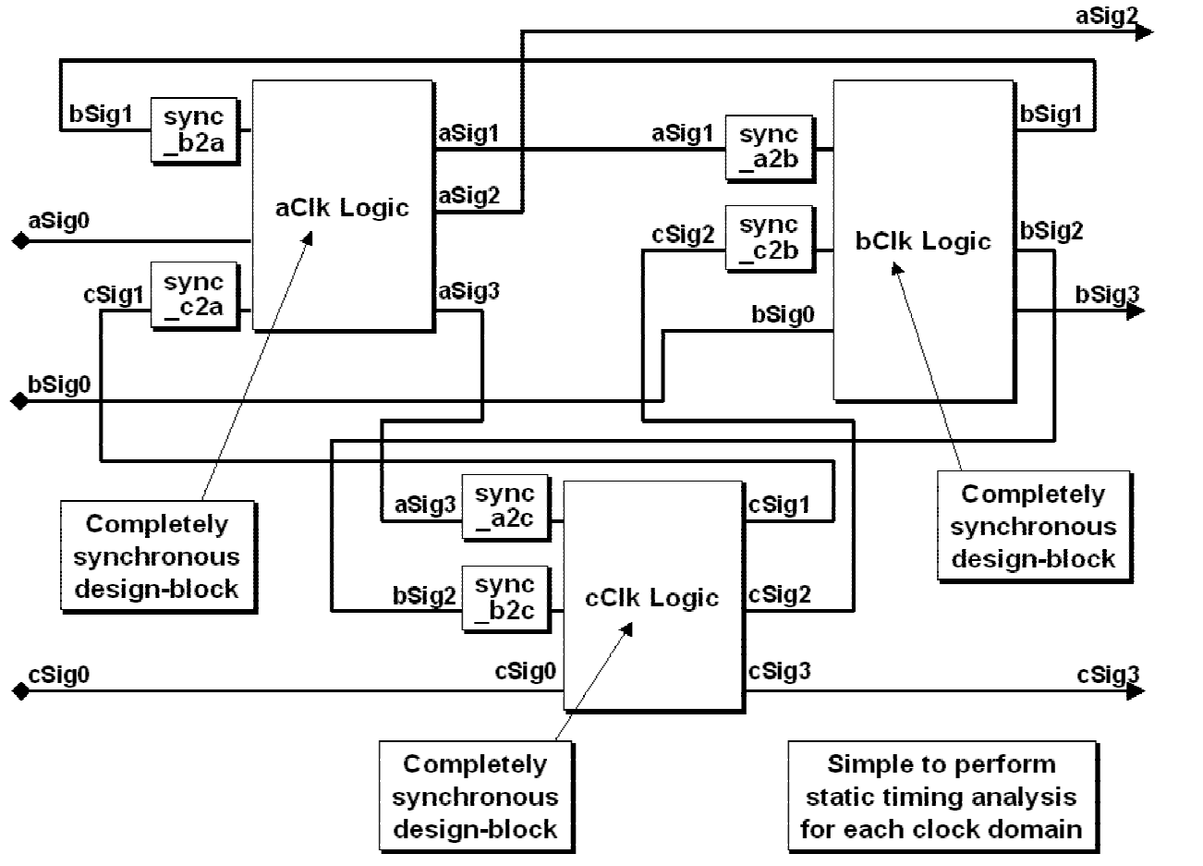
Figure 30 - Design partitioned on clock boundaries
Consider an example design with three clock domains, labeled aClk, bClk and cClk and shown
in Figure 30. In this design, all of the aClk design blocks have been grouped into a single aClk
Logic block. All of the bClk design blocks have been grouped into a single bClk Logic block
and similarly we have created a cClk Logic block. Any signal that originates in an asynchronous
clock domain passes through a synchronizer module before it is permitted to drive an input of
another Logic block.

6.3.1 Timing analysis of clock-partitioned modules
Using the clock-oriented design partitioning strategy, all of the inputs and outputs of each design
block are completely synchronous to just one clock. This is the easiest type of design to verify
using static timing analysis (STA) tools because there are no false paths in the design.
Group together all design modules that are clocked within each clock domain. One group should
be formed for each clock domain in the design. These groups will be timing verified as if each
were a separate, completely synchronous design. For each clock domain, we have a single design
block and we can easily perform worst-case (max-time / setup time checking) timing analysis,
and best-case (min-time / hold time checking) timing analysis.
Also using this clock-oriented partitioning strategy, each of the CDC boundaries has been
isolated using a synchronizer module. Each synchronizer module only includes either
synchronizer cells provided by the ASIC or FPGA vendor (preferred), or is built using flip-flops
connected as pairs to form synchronizer-equivalent cells.
If synchronizer cells are available from the ASIC or FPGA vendor, and instantiated into the
design, there will be no need to verify setup and hold times on these modules, since the vendor
should have already created a cell layout that does not violate setup or hold times between the
flip-flop stages.
If the synchronizers are synthesized from RTL code, it is most important to perform best-case
timing analysis to make sure that the flip-flops are not placed too close together in such a way
that the output from the first stage might change too quickly to satisfy the hold time requirement
of the input of the second stage. A colleague recently pointed out that worst-case timing analysis
should also be performed just in case the layout tools happen to place the two synchronizer flip-
flops far apart on the ASIC or FPGA die. I agree with this updated recommendation.
Because of the partitioning of the separate synchronizers, gate-level simulations can more easily
be configured to ignore setup and hold time violations on the first stage of each synchronizer
The static timing analysis of the RTL synchronizers requires simple set_false_path commands to
remove the inputs from the STA. We know that there are timing problems at the inputs of the
synchronizers, that is why the synchronizers are used.
By partitioning design and synchronizer blocks to permit only one clock per module, static
timing analysis becomes a significantly easier task to perform. Synthesis script commands used
to address multiple clock domain issues now become a matter of grouping, identifying false paths
and performing min-max timing analysis.

6.4 Partitioning with MCP formulations
Partitioning a design at clock boundaries into separate design blocks and synchronizer blocks
works well most of the time, but if multiple signals need to be passed between clock domains
using an MCP formulation, then some of the signals that are passed to a design block may come
from a different clock domain as shown in Figure 31.
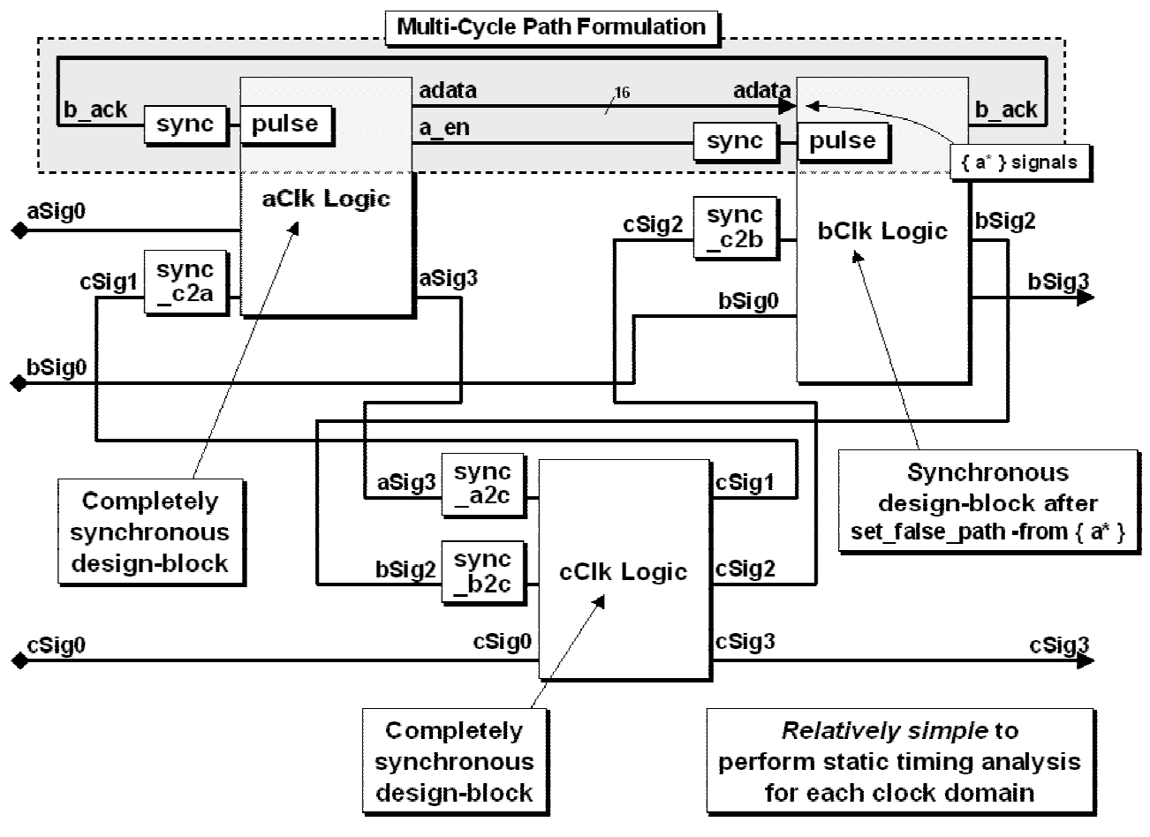
Figure 31 - Partitioned design with MCP formulation
Design blocks with asynchronous inputs can still be easily timed if a clock based naming
convention has been used for the signals in the design. Before performing STA on the design
block in question, simply exclude the asynchronous inputs from the analysis.
In general, only the inputs to the synchronizers and MCP formulation data paths require
"set_false_path" commands. If a clock-prefix naming scheme is used, then wild-cards can be
used to easily identify all asynchronous inputs. In Figure 31, to exclude the adata bus from STA
within the bClk Logic block, first execute the command:
set_false_path -from { a* }
This command should be sufficient to eliminate all asynchronous inputs from bClk STA.

7.0 Multi-clock gate-level simulation issues
Digital simulation models typically generate X's when synchronizers recognize setup and hold
time violations on CDC signals. This can frequently cause gate-level simulations to fail. What
techniques exist to address this problem?
As mentioned in section 6.3.1, signals crossing clock boundaries through a synchronizer will
experience setup and hold violations. That is why synchronizers are added to a design, to filter
out the metastability effects of a signal that changes too close to the rising edge of a receiving
clock domain clock signal.

7.1 Synchronizer gate-level CDC simulation issue
When doing gate-level simulations on a multi-clock design, the ASIC library models of flip-flops
are modeled with setup and hold time expressions to match the timing specifications of the actual
flip-flops. ASIC libraries typically model flip-flops to drive X's (unknowns) on the flip-flop
outputs when a timing violation occurs. When simulating gate-level synchronizers, setup and
hold time violations might cause ASIC libraries to issue setup and hold time error messages and
the offending signals are frequently driven to an X value. These X-values propagate to the rest of
the design causing problems when trying to verify the functionality of the entire gate-level design
as shown in Figure 31.
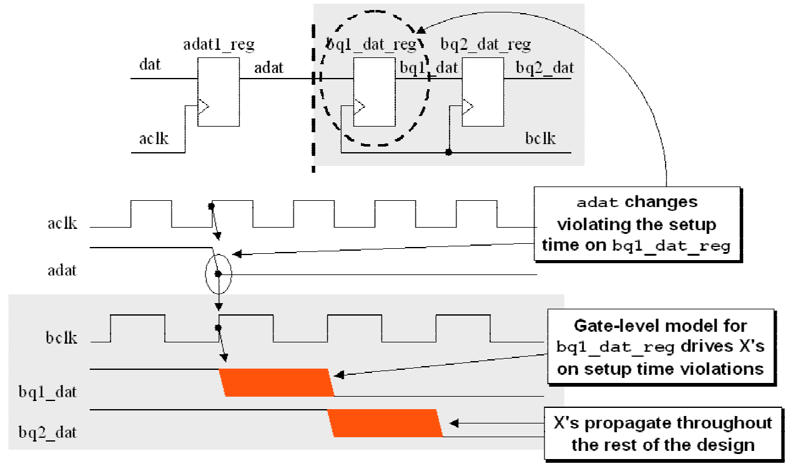
Figure 32 - Synchronizer gate-level CDC simulation waveforms

7.2 Strategies to remove X-propagation from gate-level simulations
There are a number of strategies that have been shared with me by esteemed colleagues over the
past 10 years to address issues related to unwanted propagation of X's every time a signal violates
a setup or hold time on the first stage of the synchronizer.
Since X-propagation happens when a setup or hold time is violated, almost all of the approaches
to address this issue involve changing the setup and hold times to 0 so that there can be no setup
or hold time violation, and hence, no X-propagation.
Some of the approaches are bad and others are good. Below are some of the strategies that have
been considered to address the X-propagation problem.

7.2.1 Simulator command to turn off timing checks
Most SystemVerilog simulators have a command option to ignore all timing checks, but this
would also ignore the desired timing checks for the rest of the design.

7.2.2 Change flip-flop setup and hold times to 0
It is possible to change the setup and hold time setting to zero for any ASIC library flip-flop that
is used in a synchronizer, but that would cause all setup and hold time checks of all instances of
that same type of flip-flop to be set to zero, including the flip-flops that you might want to use to
test the rest of the design.

7.2.3 Copy and modify new flip-flop models
You could make copies of flip-flops from an ASIC library and store them into a new
SystemVerilog library with different names, set to zero all setup and hold times, then modify the
design gate-level netlist, replacing all first stage synchronizer ASIC library flip-flops with the
modified library flip-flops without timing checks, but this could be an error prone and tedious
process that might have to be repeated each time a new netlist is generated or it might require the
creation of a makefile and scripts to automatically make the modifications each time a new netlist
is generated.

7.2.4 Synopsys set_annotated_check command
A useful approach to this problem suggested by Bhatnagar[5] is to use Synopsys commands to
modify the SDF backannotation of the setup and hold time on just the first stage flip-flop cells in
the design. Bhatnagar points out that the SDF file is instance based and therefore targeting the
setup and hold times for the offending cells is more easily accomplished. Bhatnagar notes:
Instead of manually removing the setup and hold-time constructs from the SDF file, a
better way is to zero out the setup and hold-times in the SDF file, only for the
violating flops, i.e., replace the existing setup and hold-time numbers with zero's.
Bhatnagar further points out that setup hold times of zero means that there can be no timing
violation, therefore no unknowns propagated to the rest of the design. The following dc_shell-t
command, given by Bhatnagar, is used to make setup and hold times zero:
set_annotated_check 0 -setup -hold -from REG1/CLK -to REG1/D
Using a creative naming convention for the output of the first stage flip-flop of a synchronizer
might make wild card expressions possible to easily backannotate all first stage flip-flop SDF
setup and hold time values to zero using very few dc_shell-t commands.
This technique works if the design is being done with Synopsys DesignCompiler tools, but what
about non-Synopsys flows?

7.3 Additional strategies to remove X-propagation
All of the strategies described in sections 7.2 through 7.2.4 were shared in my first multi-clock
design paper given in 2001. After the initial presentation a number of engineers came forward to
share additional techniques to remove X-propagation from gate level simulations. Engineers
from at least three companies described the technique very similar to the description in section
### (kudos to the engineers who attended San Jose SNUG-2001).
Since then, other engineers from many companies have shared additional techniques. Those
techniques are described in this section and I am very grateful to all the engineers who continue
to share interesting techniques with me each year. Kudos to you all!

7.3.1 Use multiple SDF files
Remember, a key to removing unwanted X-propagation is to force the setup and hold times of
the synchronizer inputs to 0, thereby removing all possible setup and hold time violations on the
synchronizer inputs.
Many engineers have told me that they actually generate two SDF files. The first SDF file has all
of the actual delays, including accurate setup and hold times, for the entire design. Then
engineers generate a second SDF file with only the first stage flip-flops included in the file. In
this file, the setup and hold times are set to 0. Some engineers build this file by hand and other
generated this file using scripts.
Engineers then read in the first SDF file using the $sdf_annotate command. Then they read in the
second SDF file, which overwrites the setup and hold times for the data inputs of the first stage
synchronizers. When reading in the two SDF files, last SDF file for each instance wins. All
timing was accurately annotated, and then the timing checks for the first stage synchronizers
were modified.
This is a clever technique that can be used with any tools flow that generates SDF files.

7.3.2 Vendor synchronizer cell with supporting SDF generation tools
Other engineers have told of a great way to approach the X-propagation problem, but the method
requires either (a) control over the cell library, or (b) a good working relationship with your
ASIC vendor.
This technique requires that a separate synchronizer cell be created with proper placement
relationship between the two flip-flop stages. To make this method work, the vendor must
provide:
(1) the actual synchronizer cell - these will be instatiated into the design.
(2) the SystemVerilog model for the synchronizer cell for simulation.
(3) SDF file generation tools that will generate an SDF file with 0-setup and 0-hold for the
synchronizer cells.
If a vendor can provide this cell and these capabilities, it will only be necessary to generate a
single SDF file with proper timing checks for the synchronizer cells.
Any ASIC of FPGA vendor who provides this capability is doing a huge favor for their customer
base. I have heard that some ASIC vendors provide this capability. I do not know of any FPGA
vendor who provides this capability. Recognizing that most modern designs are multi-clock
designs, I strongly urge all ASIC and even all FPGA vendors to provide synchronizer cells with
appropriate simulation and SDF file tool support.

7.3.3 Vendors with built-in synchronizer support
If anyone knows of a vendor who offers this support, please let me know who the vendor is with
appropriate contact information and I will periodically update this paper to honor vendors who
offer this capability to us, the design community.
Vendor list:
(No vendors listed as of this release of this paper)

7.4 Multiple SDF files for gate-level CDC simulations
Immediately after giving my first multi-clock presentation in 2001, engineers from at least three
different companies came up after my presentation to share the following great technique to
address X-propagation in gate-level simulations.
The technique involved writing out the full SDF timing file and then either manually or by using
a script, generate a second SDF file for just the first-stage flip-flops of all synchronizer modules.
The second SDF file set all setup and hold times to 0 and then the two SDF files are applied to
the design using $sdf_annotate commands. The first SDF file annotates all of the actual timing to
the entire design and then the second SDF file is read to over-write the setup and hold times for
the first stage synchronizers.
The advantage of this technique is that it can be used for all designs using all tools, not just
Synopsys ASIC designs. This is a highly recommended technique.

7.5 Force synchronizer notifier inputs to a fixed value
The built-in timing checks for Verilog and SystemVerilog setup and hold time checks ($setup,
$hold, and $setuphold) have an optional notifier output. This notifier output toggles from 0-1-X-
Z whenever a timing violation is detected.
Most ASIC and FPGA flip-flop models are built from Verilog User Defined Primitives (UDPs)
and the notifier signal is typically listed as one of the inputs to the UDP table. Whenever the
notifier input toggles (caused by a timing violation), the flip-flop output goes unknown and that
unknown is what is visible on the output of the gate-level flip-flop models. The notifier on these
first-stage flip-flop models can be force to a logic level to prevent them from toggling and
causing the flip-flop outputs to go unknown during simulation.
One clever technique used by at least one company forces the timing violation notifiers of the
first-stage synchronizer flip-flops to be forced to one logic level so they can never toggle and
trigger X's into the flip-flop models.

7.6 ASIC & FPGA library cell synchronizers
ASIC and FPGA providers could make CDC design much easier to do if they would provide
fully characterized synchronizer cells that could be instantiated into a design. Advanced ASIC
vendors provide:
(1) the characterized synchronizer cell.
(2) the Verilog model to simulate the synchronizer cell.
(3) the SDF generator to generate SDF files that annotate the setup and hold time on a
synchronizer cell to 0 to avoid the X-generation when a signal violates setup or hold times
while crossing CDC boundaries.
I know of no FPGA provider that provides this capability, but a forward thinking FPGA provider
would provide such cells for their advanced multi-clock design customers.

7.7 Simulation model with random delay insertion
An interesting model that synthesizes to the correct synchronizer for design, but simulates with
random cycle delays has been suggested by multiple colleagues.
The block diagram for the model is shown in Figure 33, and the SystemVerilog code to support
this model is shown in Example 6.
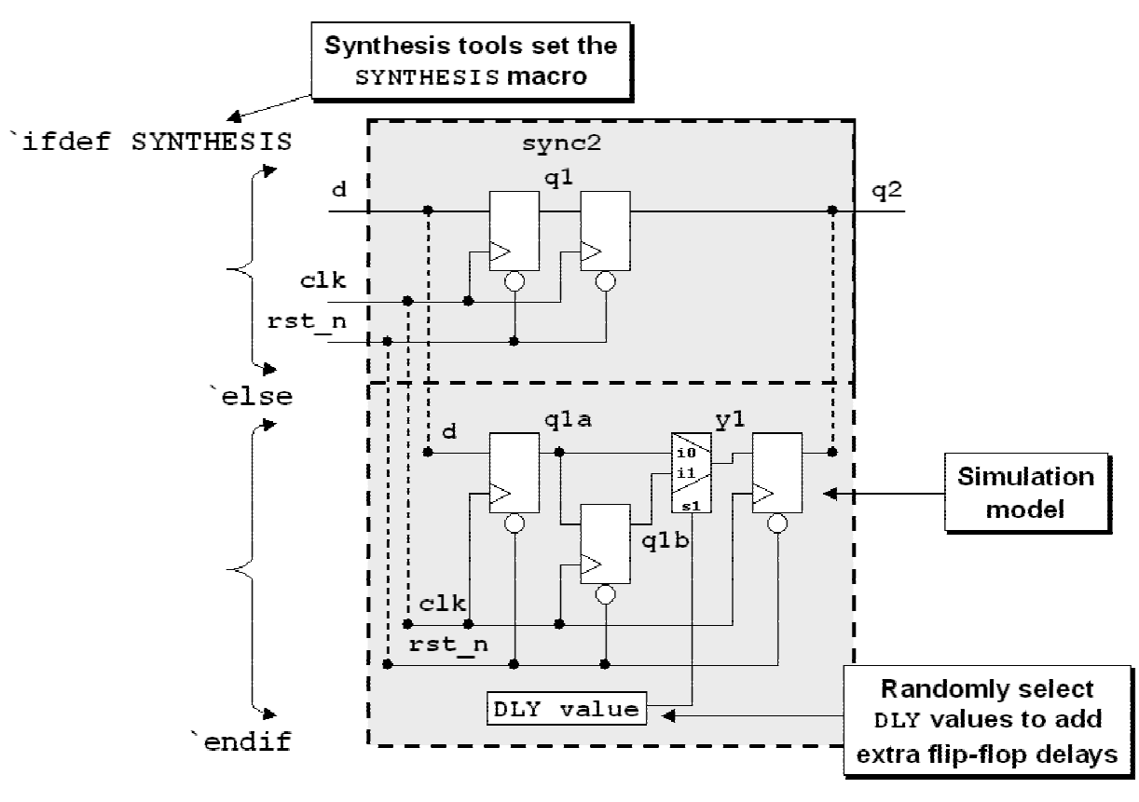
Figure 33 - Sample ASIC & FPGA synchronizer cell for synthesis and simulation
As can be seen in the block diagram, the model is designed to produce either a synthesizble
synchronizer model or to be used as a simulation model with selectable delays.
The IEEE Std 1364.1-2002 Verilog RTL Synthesis Standard[6] requires that a compliant
synthesis tool set the SYNTHESIS macro before reading in any Verilog models. Although most
synthesis tools have largely ignored many of the requirements of the IEEE Verilog synthesis
standard, most tools have implemented this nice SYNTHESIS macro requirement.
Tools that set the SYNTHESIS macro before reading this sync2 SystemVerilog code will select
the code to infer the two flip-flop synchronizer.
Simulators, which do not set the SYNTHESIS macro, will read the sync2 model, ignore the code
intended for a synthesizable model and will simulate the model in the `else portion of the code.
The model is parameterized so the same model can be used with the default parameter SIZE of
1-bit in width for simple 1-bit CDC signals, or the model can be instantiated with the SIZE
parameter set to a multi-bit width so that the synchronizer can be used to capture and synchronize
multi-bit buses such as gray code counters.
module sync2 #(parameter SIZE=1)
(output logic [SIZE-1:0] q2,
input logic [SIZE-1:0] d,
input logic clk, rst_n);
`ifdef SYNTHESIS
logic [SIZE-1:0] q1;
always_ff @(posedge clk or negedge rst_n)
if (!rst_n) {q2,q1} <= '0;
else {q2,q1} <= {q1,d};
`else
logic [SIZE-1:0] y1, q1a, q1b;
logic [SIZE-1:0] DLY = '0;
assign y1 = (~DLY & q1a) | (DLY & q1b);
always_ff @(posedge clk or negedge rst_n)
if (!rst_n) {q2,q1b,q1a} <= '0;
else {q2,q1b,q1a} <= {y1,q1a,d};
`endif
endmodule
Example 6 - SystemVerilog model for ASIC & FPGA synchronizer cell
The simulation portion of the model includes a default declaration for a SIZE-ed variable called
DLY. By default the DLY variable is initialized to 0, which causes the entire sync2 model to
simulate with the default of two flip-flop delays, but the DLY variable can be hierarchically set
from the testbench to a reproducible 1's and 0's random value to cause some of the bits in the bus
to pass through three flip-flop stages while others pass through only two flip-flop stages. This can
model the behavior of a set of synchronizers where some bits are captured on an earlier clock
edge than others and allow the simulation to observe how well the design behaves with small
skews in the multi-bit data path.

8.0 Summary & conclusions
Clock Domain Crossing (CDC) errors can cause serious design failures. These expensive failures
can be avoided by following a few critical guidelines and using well established verification
techniques.

8.1 Recommended 1-bit CDC techniques
When passing one bit between clock domains:
• register the signal in the sending clock domain to remove combinational settling.
• synchronize the signal into the receiving clock domain. A Multi-Cycle Path (MCP)
formulation may be necessary.

8.2 Recommended multi-bit CDC techniques
When passing multiple control or data signals between clock domains, use one of the following
strategies:
• Consolidate - first attempt to combine multiple signals into a 1-bit representation in the
sending clock domain before synchronizing the signal into the receiving domain.
• Use Multi-Cycle Path (MCP) formulations to pass multiple signals across clock domains
• Use FIFOs to pass multi-bit buses, either data or control buses.
• Use gray code counters.

8.3 Recommended naming conventions and design partitioning
Use a clock-based naming convention.
As much as possible, partition the design sub-blocks into completely synchronous 1-clock
designs.

8.4 Recommended solutions to multi-clock gate-level CDC simulations
There are multiple useful solutions to the CDC X-propagation simulation issues during gate-level
simulation:
• Use a Synopsys switch to generate 0-setup and 0-hold times for first stage flip-flops on
synchronizers. Works okay with Synopsys tools only.
• Use multiple SDF files - good technique described later in this section.
• Vendor provides a synchronizer cell and appropriate SDF tools - great solution if your ASIC
or FPGA vendor provides the models and tools (very few do - ask you ASIC & FPGA vendors
to support this feature)
• Use creative SystemVerilog models to model synchronization problems.
The techniques described in this paper were designed to facilitate robust development and
verification of multi-clock designs.

9.0 Acknowledgements
My thanks to the hundreds of colleagues and students who have shared interesting multi-
asynchronous clock CDC design techniques over the past eight years.

10.0 References
[1]
Clifford E. Cummings, “Simulation and Synthesis Techniques for Asynchronous FIFO Design,”
SNUG 2002 - www.sunburst-design.com/papers/CummingsSNUG2002SJ_FIFO1.pdf
[2]
Clifford E. Cummings, “Synthesis and Scripting Techniques for Designing Multi-Asynchronous
Clock Designs,” SNUG 2001 -
www.sunburst-design.com/papers/CummingsSNUG2001SJ_AsyncClk.pdf
[3]
Don Mills & Clifford E. Cummings, “RTL Coding Styles That Yield Simulation and Synthesis
Mismatches” SNUG 1999 -
www.sunburst-design.com/papers/CummingsSNUG1999SJ_SynthMismatch.pdf
[4]
Frank Gray, "Pulse Code Communication." United States Patent Number 2,632,058. March 17,
1953.
[5]
Himanshu Bhatnagar, Advanced ASIC Chip Synthesis, Second Edition, Kluwer Academic
Publishers, 2002.
[6]
"IEEE Std. 1364.1 - 2002 IEEE Standard for Verilog Register Transfer Level Synthesis," IEEE
Computer Society, IEEE, New York, NY, IEEE Std 1364.1-2002
[7]
Mark Litterick, “Pragmatic Simulation-Based Verification of Clock Domain Crossing Signals and
Jitter Using SystemVerilog Assertions,” DVCon 2006
www.verilab.com/files/sva_cdc_paper_dvcon2006.pdf
[8]
Real Intent, Inc. (white paper), “Clock Domain Crossing Demystified: The Second Generation
Solution for CDC Verification,” February 2008 - www.realintent.com
[9]
Steve Golson, personal communication
[10] William J. Dally and John W. Poulton, Digital Systems Engineering, Cambridge University Press,
1998
[11] Wikipedia: http://en.wikipedia.org/wiki/Clock_Domain_Crossing_Verification

11.0 Author & Contact Information
Cliff Cummings, President of Sunburst Design, Inc., is an independent EDA consultant and
trainer with 26 years of ASIC, FPGA and system design experience and 16 years of
SystemVerilog, synthesis and methodology training experience.
Mr. Cummings has presented more than 80 SystemVerilog seminars and training classes in the
past five years and was the featured speaker at the world-wide SystemVerilog NOW! seminars.
Mr. Cummings has participated on every IEEE & Accellera SystemVerilog, SystemVerilog
Synthesis, SystemVerilog committee, and has presented more than 40 papers on SystemVerilog
& SystemVerilog related design, synthesis and verification techniques.
Mr. Cummings holds a BSEE from Brigham Young University and an MSEE from Oregon State
University.
Sunburst Design, Inc. offers World Class Verilog & SystemVerilog training courses. For more
information, visit the www.sunburst-design.com web site.
Email address: cliffc@sunburst-design.com
An updated version of this paper can be downloaded from the web site: www.sunburst-
design.com/papers
(Last updated September 26, 2008)

12.0 Appendix
This appendix includes the source code for the MCP formulation with acknowledge feedback
and the 1-deep, 2-register FIFO synchronizer.

12.1 Common sync2 model - used by MCP formulation and FIFO synchronizer
The sync2 model is common to both the MCP formulation with ready-acknowledge design
(source code in section 12.2) and the multi-bit 1-deep / 2-register FIFO synchronizer (source
code in section 12.3).
// sync signal to different clock domain
module sync2 (
output logic q,
input logic d, clk, rst_n);
logic q1; // 1st stage ff output
always_ff @(posedge clk or negedge rst_n)
if (!rst_n) {q,q1} <= '0;
else {q,q1} <= {q1,d};
endmodule
Example 7 - sync2.sv code

12.2 MCP formulation with ready-acknowledge source code
This model requires the sync2 model shown in section 12.1.
// Pulse Generator
module plsgen (
output logic pulse, q,
input logic d,
input logic clk, rst_n);
always_ff @(posedge clk or negedge rst_n)
if (!rst_n) q <= '0;
else q <= d;
assign pulse = q ^ d;
endmodule
Example 8 - plsgen.sv code
module asend_fsm (
output logic aready, // ready to send next data
input logic asend, // send adata
input logic aack, // acknowledge receipt of adata
input logic aclk, arst_n);
enum logic {READY = '1,
BUSY = '0} state, next;
always_ff @(posedge aclk or negedge arst_n)
if (!arst_n) state <= READY;
else state <= next;
always_comb begin
case (state)
READY: if (asend) next = BUSY;
else next = READY;
BUSY : if (aack) next = READY;
else next = BUSY;
endcase
end
assign aready = state;
endmodule
Example 9 - asend_fsm.sv code
module back_fsm (
output logic bvalid, // data valid / ready to load
input logic bload, // load data / send acknowledge
input logic b_en, // enable receipt of adata
input logic bclk, brst_n);
enum logic {READY = '1,
WAIT = '0} state, next;
always_ff @(posedge bclk or negedge brst_n)
if (!brst_n) state <= WAIT;
else state <= next;
always_comb begin
case (state)
READY: if (bload) next = WAIT;
else next = READY;
WAIT : if (b_en) next = READY;
else next = WAIT;
endcase
end
assign bvalid = state;
endmodule
Example 10 - back_fsm.sv code
module bmcp_recv (
output logic [7:0] bdata,
output logic bvalid, // bdata valid
output logic b_ack, // acknowledge signal
input logic [7:0] adata, // unsynchronized adata
input logic bload, // load data and acknowledge receipt
input logic bq2_en, // synchornized enable input
input logic bclk, brst_n);
logic b_en; // enable pulse from pulse generator
// Pulse Generator
plsgen pg1 (.pulse(b_en), .q(), .d(bq2_en),
.clk(bclk), .rst_n(brst_n), .*);
// data ready/acknowledge FSM
back_fsm fsm (.*);
// load next data word
assign bload_data = bvalid & bload;
// toggle-flop controlled by bload_data
always_ff @(posedge bclk or negedge brst_n)
if ( !brst_n) b_ack <= '0;
else if (bload_data) b_ack <= ~b_ack;
always_ff @(posedge bclk or negedge brst_n)
if ( !brst_n) bdata <= '0;
else if (bload_data) bdata <= adata;
endmodule
Example 11 - bmcp_recv.sv code
module mcp_blk #(parameter type dat_t = logic [7:0]) (
output logic aready, // ready to receive next data
input logic [7:0] adatain,
input logic asend,
input logic aclk, arst_n,
output logic [7:0] bdata,
output logic bvalid, // bdata valid (ready)
input logic bload,
input logic bclk, brst_n);
logic [7:0] adata; // internal data bus
logic b_ack; // acknowledge enable signal
logic a_en; // control enable signal
logic bq2_en; // control - sync output
logic aq2_ack; // feedback - sync output
sync2 async (.q(aq2_ack), .d(b_ack), .clk(aclk), .rst_n(arst_n));
sync2 bsync (.q(bq2_en), .d(a_en), .clk(bclk), .rst_n(brst_n));
amcp_send alogic (.*);
bmcp_recv blogic (.*);
endmodule
Example 12 - mcp_blk.sv code
module amcp_send (
output logic [7:0] adata,
output logic a_en, aready,
input logic [7:0] adatain,
input logic asend,
input logic aq2_ack,
input logic aclk, arst_n);
logic aack; // acknowledge pulse from pulse generator
// Pulse Generator
plsgen pg1 (.pulse(aack), .q(), .d(aq2_ack),
.clk(aclk), .rst_n(arst_n));
// data ready/acknowledge FSM
asend_fsm fsm (.*);
// send next data word
assign anxt_data = aready & asend;
// toggle-flop controlled by anxt_data
always_ff @(posedge aclk or negedge arst_n)
if ( !arst_n) a_en <= '0;
else if (anxt_data) a_en <= ~a_en;
always_ff @(posedge aclk or negedge arst_n)
if ( !arst_n) adata <= '0;
else if (anxt_data) adata <= adatain;
endmodule
Example 13 - acmp_send.sv code

12.3 Multi-bit 1-deep / 2-register FIFO synchronizer source code
This model requires the sync2 model shown in section 12.1.
module wctl (
output logic wrdy, wptr, we,
input logic wput, wq2_rptr,
input logic wclk, wrst_n);
assign we = wrdy & wput;
assign wrdy = ~(wq2_rptr ^ wptr);
always_ff @(posedge wclk or negedge wrst_n)
if (!wrst_n) wptr <= '0;
else wptr <= wptr ^ we;
endmodule
Example 14 - wctl.sv code
`timescale 1ns/1ns
module cdc_syncfifo #(parameter type dat_t = logic [7:0]) (
// Write clk interface
input dat_t wdata,
output logic wrdy,
input logic wput,
input logic wclk, wrst_n,
// Read clk interface
output dat_t rdata,
output logic rrdy,
input logic rget,
input logic rclk, rrst_n);
logic wptr, we, wq2_rptr;
logic rptr, rq2_wptr;
wctl wctl (.*);
rctl rctl (.*);
sync2 w2r_sync (.q(rq2_wptr), .d(wptr), .clk(rclk), .rst_n(rrst_n));
sync2 r2w_sync (.q(wq2_rptr), .d(rptr), .clk(wclk), .rst_n(wrst_n));
// dual-port 2-deep ram
dp_ram2 #(dat_t) dpram (.q(rdata), .d(wdata),
.waddr(wptr), .raddr(rptr),
.we(we), .clk(wclk), .*);
endmodule
Example 15 - cdc_syncfifo.sv code
// dual-port 2-deep ram
module dp_ram2 #(parameter type dat_t = logic [7:0])
(output dat_t q,
input dat_t d,
input logic waddr, raddr, we, clk);
dat_t mem [0:1];
always_ff @(posedge clk)
if (we) mem[waddr] <= d;
assign q = mem[raddr];
endmodule
Example 16 - Dual Port Ram code - dp_ram2.sv
module rctl (
output logic rrdy, rptr,
input logic rget,rq2_wptr,
input logic rclk, rrst_n);
typedef enum {xxx, VALID} status_e;
status_e status;
assign status = status_e'(rrdy);
assign rinc = rrdy & rget;
assign rrdy = (rq2_wptr ^ rptr);
always_ff @(posedge rclk or negedge rrst_n)
if (!rrst_n) rptr <= '0;
else rptr <= rptr ^ rinc;
endmodule
Example 17 - rctl.sv code

